Final Year Project Report
Project Name: One Window University Portal



Submitted By:
Junaid khan (F20242661193)
Muhammad Abbas (F20242661172)
Muhammad Awais (F20242661168)
Muhammad Abdullah Bhatti (F20242661170)
Hassam ul Haq (F20242661200)

Session
Fall 2024

University of Management and Technology
C-II Johar Town Lahore Pakistan
Dedication
We want to dedicate this to our parents, professors especially Sir Ammar Haider for his unprecedented support and guidance throughout our university life.

Final Approval

- Head of Department ______________________
Department of Informatics & Systems
School of Systems & Technology
UMT Lahore

- Director (Final Year Projects-CS) ______________________
Department of Computer Science.
School of Systems & Technology
UMT Lahore

- Supervisor ______________________
- Department of Informatics & Systems.
- School of Systems & Technology
UMT Lahore

- Co-Supervisor ______________________

Acknowledgment
We had made this website with lots of efforts with backing of our teachers who will help us to stay motivated and focused on our project. We had learned a lot from this project and we will keep on learning to become a better version of ourselves.
As a young software engineers and entrepreneurs, we appreciate to have chance to learn from all the expertise of the people who were helping us creating this project.
We are thankful to each and every people who helped us throughout our project and corrected our mistakes and remained side by side which made our morale high and we were able to complete this project.

Project Title:
One Window University Portal
Objective:
The objective of our project to integrate the three different portals in a Single Window University Portal, allowing seamless transition and increasing accessibility and making everything easier.
Undertaken by:
Junaid Khan (F20242661193)
Hassam Ul Haq (F20242661200)
Muhammad Abbas (F20242661172)
Muhammad Awais (F20242661170)
Muhammad Abdullah Bhatti (F20242661170)
Starting Date:
14 October 2025
Completion Date:
20 January 2026
Tools Used:
React.js: Interface
Vite: Bundling
Redux Toolkit: State
Tailwind CSS: Styling
Framer Motion: Animation
Node.js: Runtime
Express.js: Server
MongoDB: Database
Mongoose: Modelling
Cloudinary: Storage
JWT: Authentication
Argon2: Hashing
Speakeasy: MFA
VS Code: Editor
Postman: Testing
Git & GitHub: Versioning
Nodemailer: Email
Stripe API: Payments
Operating System :
All operating systems
Documentation:
Software Requirement specification
Plagiarism Report
Abstract
The One Window University Portal is a high availability enterprise solution developed through this research project, aimed at addressing the issues associated with fragmented academic administration systems. The unified platform merges three missions-critical pieces: a Learning Management System (LMS), a Student Information System (SIS), and an Enterprise Resource Planning System (ERP).
The system utilizes a Single Sign-On (SSO) infrastructure based on session tokens with HMAC signatures along with Role-Based Access Control (RBAC) for secure and streamlined inter-module switching. For the student population, the system allows real-time academic monitoring with automatic GPA/CGPA computation, degree audits simulation, as well as secure management of financial transactions as per PCI DSS requirements. Faculty-member-focused modules are specialized towards improved pedagogical processes through automatic attendance auditing, plagiarism software interface management, along with a multi-step result processing procedure.
In order to meet the strict organizational requirements of security, the deployment requires Multi-Factor Authentication for the administrative levels and the use of AES-256 encryption for data at rest in order to ensure the integrity of the sensitive Personally Identifiable Information (PII) handled in the organization. In this way, the integrated academic and financial data streams provided through the One Window University Portal streamline the transparency and administrative throughput of the organization, in addition to the provision of a scalable technological infrastructure in the higher education sector.
Revision Chart

Version | Primary Author(s) | Description of Version | Date Completed
1.0 | Junaid Khan (F20242661193)  Muhammad Abbas (F20242661170)  Muhammad Abdullah (F20242661172)  Muhammad Awais (F20242661168)  Hassam ul Haq (F20242661200) | This is the completed draft of the first capstone project. There is a total of 5 chapters.  1. Introduction  2. Domain analysis  3. Requirement Analysis  4. Data Flow Diagram (OPTIONAL)  5. System Design | 30 October 2025

Version | Primary Author(s) | Description of Version | Date Completed
2.0 | Junaid Khan (F20242661193)  Muhammad Abbas (F20242661170)  Muhammad Abdullah (F20242661172)  Muhammad Awais (F20242661168)  Hassam ul Haq (F20242661200) | This is the completed draft of the first capstone project. There is a total of 12 chapters.  1. Introduction  2. Domain analysis  3. Requirement Analysis  4. Data Flow Diagram (OPTIONAL)  5. System Design  6.Implementation Details  7.Testing  8.Results  9.Conclusion  10.Future Work  11.Bibilography  12.Appendix | 20 January 2026

Contents
Contents 1
Table of tables 5
Definitions and Acronyms 6
1 Introduction 9
1.1 Motivations 9
1.2 Project Overview 9
1.2.1 Core Problems 9
1.2.2 System Goals: 10
1.2.3 System functions: 10
1.2.4 System Attributes: 10
1.3 Problem Statement 11
1.4 Objectives 11
1.4.1 Security and Identity Management: 11
1.4.2 Efficiency - Academic and Pedagogical: 12
1.4.3 Optimization Administrative and Financial: 12
1.4.4 Quality Assurance and Performance: 12
2 Domain Analysis 14
2.1 Customer 14
2.2 Stakeholders 14
2.3 Social and Socio-Economic Impact 14
2.3.1 Optimization of Administrative Throughput and Accuracy: 15
2.3.2 Increased Financial and Academic Clarity: 15
2.3.3 Strategic Reduction in Institutional Overhead: 16
2.3.4 Data-Driven Academic Governance: 16
2.4 Critical System Dependencies 16
2.5 Related System Competitive Advantage 17
2.5.1 Comparative Feature Analysis: 17
3 Requirements analysis 19
3.1 Functional Architecture 19
3.1.1 Core System and Authentication Services (FR-C) 19
3.1.2 Student Portal Services (FR-S) 19
3.1.3 Faculty Portal Services (FR-F) 20
3.1.4 Administrative & Management Services (FR-A) 20
3.2 User Characteristics and Actors 21
3.3 Non-Functional Requirements 21
3.4 System Requirements 24
3.4.1 SR-1: Core Technology Stack 25
3.4.2 SR-2: External API & Integration Libraries 25
3.5 Functional Requirements (FR) 26
3.6 List of Actors 33
3.7 Use Case Modeling 34
3.7.1 List of Use Cases 34
3.8 System use case diagram 36
3.9 Extended use cases 36
3.9.1 Extended Use Case 1: User Authentication & SSO 36
3.9.2 Extended Use Case 2: Course Registration 37
3.9.3 Extended Use Case 3: Fee Payment Processing 39
3.9.4 Extended Use Case 4: Secure Result Submission 40
3.9.5 Extended Use Case 5: Attendance Auditing 42
3.9.6 Extended Use Case 6: What-If Analysis (GPA Projection) 44
3.9.7 Extended Use Case 7: Curriculum Version Control 45
3.9.8 Extended Use Case 8: Document Request & Tracking 47
3.9.9 Extended Use Case 9: LMS Course Content Management 48
3.9.10 Extended Use Case 10: Scholarship & Financial Aid Allocation 50
3.9.11 Extended Use Case 11: Section Allocation & Resource Management 51
3.9.12 Extended Use Case 12: Faculty Research & Publication Tracking 53
3.10 User interfaces (mock screens) 55
4 Data flow diagram (optional) 66
4.1 Data Flow Diagram Level 0 66
4.2 Data Flow Diagram Level 1 66
4.3 Data Flow Diagram Level 2 66
5 System Design 67
5.1 System Architecture 67
5.1.1 Architectural Tier 67
5.2 System Architecture 67
5.3 Class Diagram 68
5.4 Activity Diagrams 69
5.5 Collaboration Diagrams 77
5.6 Use Case Diagrams 77
5.7 ERD 81
5.8 Data Dictionary 81
6 Implementation Details 86
6.1 Development Setup 86
6.1.1 Technology Stack: 86
6.1.2 Programming Languages: 86
6.1.3 Development Tools 86
6.2 Core System Implementation 87
6.2.1 Security Implementation 87
6.2.2 Algorithm 1: Authentication and SSO Flow 87
6.2.3 Algorithm 2: Course Registration Validation 88
6.2.4 Algorithm 3: GPA/CGPA Calculation 88
6.3 Constraints 89
6.3.1 Technical and System Constraints 89
6.4 Operational Assumptions 90
6.5 System Restrictions and Limitations 90
7 Results/Outputs/statistics 91
7.1 System Completion Status 91
7.2 Accuracy and Correctness 91
7.3 Role-Based Access Validation (RBAC) 92
7.4 Performance and Scalability Observations 93
8 CONCLUSION 95
8.1 Summary of Achieved Objectives 95
8.2 System Strengths and Technical Rigor 95
8.3 Academic and Institutional Contribution 96
8.4 Concluding Statement 96
9 Future Work 98
9.1 AI-Driven Predictive Analytics 98
9.2 Mobile Application Expansion 98
9.3 Blockchain-Verified Transcripts and Credentials 99
9.4 Advanced Business Intelligence (BI) Dashboards 99
9.5 Integration with National Education Systems 99
10 References 101
11 APPENDIXES 102
11.1 Technical Glossary 102
11.2 System Abbreviations 103
11.3 Supplementary Documentation (Appendix) 104

Table of tables
Table 1: Table Of Acronyms & Definition 6
Table 2: List Of Stakeholders 12
Table 3: Comparison Analysis 16
Table 4: Non-Functional Requirements 22
Table 5: Student Portal Features (Fr-S) 27
Table 6: Faculty Portal Features (Fr-F) 29
Table 7: Admin / Management Features 31
Table 8: System Actors, Roles, And Privilege Mapping 32
Table 9: System Use Case 33
Table 10: User Authentication & Sso 35
Table 11: Course Registration 37
Table 12: Fee Payment Processing 38
Table 13: Secure Result Submission 40
Table 14: Attendance Auditing 41
Table 15: What-If Analysis (Gpa Projection) 43
Table 16: Curriculum Version Control 44
Table 17: Document Request & Tracking 46
Table 18: Lms Course Content Management 47
Table 19: Scholarship & Financial Aid Allocation 49
Table 20: Section Allocation & Resource Management 51
Table 21: Faculty Research & Publication Tracking 52
Table 22: Data Dictionary 59
Table 23: Detailed Rbac Functionality Matrix 68
Table 24: System Abbreviations 79

Definitions and Acronyms
Acronym | Definition
AES-256 | Advanced Encryption Standard with a 256-bit key, utilized for securing sensitive PII and financial data at rest.
ERP | Enterprise Resource Planning; the component managing university business operations, including HR, payroll, and financial control.
HMAC | Grade Point Average and Cumulative Grade Point Average; metrics calculated to two decimal places to represent student academic performance
LMS | Hash-based Message Authentication Code; used for signing session tokens to ensure secure, non-repudiable user access.
MFA: | Multi-Factor Authentication; a mandatory secondary verification layer for administrative roles (UR-03) to prevent unauthorized access.
PCI DSS | Payment Card Industry Data Security Standard; the compliance framework required for the secure processing of fee payments via integrated gateways.
RBAC | Role-Based Access Control; the primary security policy restricting system modules based on defined user roles (UR-01 to UR-05).
SIS: | Student Information System; the core database for managing student enrollment, academic records, and graduation audits.
SSO: | Single Sign-On; an authentication architecture allowing users to access all integrated modules with a single set of credentials.
TLS 1.2+ | Transport Layer Security; the cryptographic protocol ensuring secure data transmission across the portal.
Audit Log | An immutable, chronological record of system activities used to track sensitive CRUD operations and administrative changes.
Course Roster | A comprehensive list of students enrolled in a specific section, accessible by authorized faculty and coordinators.
Degree Audit | An automated process that evaluates a student's completed credits against program requirements to determine graduation eligibility.
Non-Repudiation | A security state ensuring that a user cannot deny the validity of an activity or transaction performed within the portal.
User Provisioning | The administrative process of defining, creating, and managing user accounts and their associated permissions.
Table 1: Table of acronyms & definition

Introduction

Motivations
Contemporary institutions of higher learning operate in a fragmented environment where the crucial admin and academic functions run on different software platforms. This is because Student Information Systems (SIS), Learning Management Systems (LMS), and Enterprise Resource Planning (ERP) system in institutions cannot work together. Thus, the need for this project is based on the reality where there is an important need to fix such inefficiencies by integrating an architecture with aggregated data feeds presented through a single high-availability interface.

1.2 Project Overview
The One Window University Portal is an enterprise-level solution fully functional and set up for streamlining various operations of a university within an integrated web and mobile-compatible application. The software forces the amalgamation of various modules of the Student Information System (SIS), Learning Management System (LMS), and Enterprise Resource Planning (ERP) into a single role-based access application.

1.2.1 Core Problems
The evolution of this portal has been made necessary due to several critical shortcomings of the present administration and management structure:
- Fragmented Data Ecosystems: The necessary data is now dispersed and locked away in different platforms. This has resulted in very poor levels of synchronization between the academic and finance departments.
- Authentication Redundancy: Users are required to handle and verify various credential sets to gain access to basic university services, thus increasing the attack surface when it comes to authentication and causing ‘authentication fatigue’.
- Manual Processing Bottlenecks: High-stakes processes such as the authorization of results, reconciliation of fees, and analysis of degrees involve manual processing and have potential human errors and associated latencies.
- Realtime Non-Auditability: The fact that logs are not centrally auditable and unreputable in nature means that the system is not traceable in a real-time manner for critical Issues like CRUD operations and securities.

1.2.2 System Goals:
The prime purpose of this portal is to facilitate a high integrity digital platform for realizing the following:
- Centralization: All academic and funding details should flow through a centralized interface that is non-repudiable.
- Security Standard: Secure with standard levels of security using AES-256 encryption and multi-factor authorization for administration login details.
- Operations Transparency: Provide real-time access to students' performance, absence records, and financial payment details to all concerned parties.

1.2.3 System functions:
The portal provides a variety of automation workflows that are designed for specific user roles:
- Authentication Services: Facilitating Single Sign-On (SSO) and role-based security (UR-01 through UR-05) for dynamically loading relevant dashboards for authenticated users.
- Academic Management: It assists in automatic GPA/CGPA calculation, attendance tracking, and degree audits.
- Financial Operations: Manages fee payment processes following PCI DSS standards, installment plan setup, and digital receipt retrieval.
- Pedagogical Administration: Enables teachers to see the list of students, prepare material for the lecture, and also accomplish complex tasks like the submission of results

1.2.4 System Attributes:
The architecture is dependent on important technical factors, such as:
- Cohesion: The measure to which all aspects of the architecture.
- Integrity: It maintains immutable detailed audit trail records for all significant CRUD operations and system access transactions so that it can assure smooth flow.
- Availability: Facilitates high availability to access read-only transactions with a target response time of 2-3 seconds under average loads ensuring speed and reliability.
- Scalability: The system was designed with a modular architecture that allows for easy scalability by incorporating more academic programs and a bigger user base without regression plus the integration of all three portals in a single window.
- Security: Must use TLS version 1.2 or higher for all data. This is to ensure the security of Personally Identifiable Information and academic records ensuring all the necessary protocols.

Problem Statement
The dependence on the fractured university system comes with a sub-optimal user experience that is formed by redundancy of operations and a discrepancy of data. Notably, some of the problems that arise from the system include the following:
- Authentication Fatigue: The need to deal with different credentials for different modules leads to increased security risks and decreased accessibility.
- Administration Inefficiency: Since the statuses, credit hour calculations, and dues payments are assessed manually in different systems, the administrative process becomes inefficient.
- Lack of Real-Time Transparency: The current system does not provide for the reflection of changes such as assignments turned in or financial transactions within the campus environment in real time.

Objectives
The main target of this research is to design and implement an efficient & secure portal system with the following technical objective:

1.4.1 Security and Identity Management:
- Centralized Authentication: A Single Sign-On (SSO) system needs to be implemented using HMAC-signed session tokens in order to mitigate the authentication fatigue issue.
- Multi-Factor Authentication (MFA): Enforce secondary authentication for administrative roles (UR-03) and optional authentication for other types of user roles to minimize the risk of unauthorized access to the sensitive institutional data.
- Data Protection: Implement AES-256 encryption for the data that is stored, as well as TLS 1.2+ encryption for all data that is transmitted.

1.4.2 Efficiency - Academic and Pedagogical:
- Automation of Academic Auditing: Develop a rules engine that computes real-time GPA/CGPA to two decimal places, and offer simulation facilities for "What-If" analysis of degrees.
- Attendance Integrity: Develop an automated attendance tracking and auditing system, where notifications will be sent to the student when they go below the required 75%.
- Integrated Learning Management: Streamline course content delivery and assessment processes and enable faculty to manage electronic rosters and unit organization of lecture materials.

1.4.3 Optimization Administrative and Financial:
  - Consolidated Financial Workflows: Facilitate PCI DSS compliant fee management and process payments via multiple gateways with authenticated digital receipts in real-time to ensure secure payments.
  - Curriculum Version Control: Provide administrators with a master interface for controlling the program life cycle and course offerings, together with an unalterable audit trail of all structural changes allowing back tracking if needed.
  - User Provisioning and RBAC: Provide an extremely detailed Role-Based Access Control (RBAC) engine to manage the permissions for five different classes of users - UR-01 to UR-05-with data isolation and specialized dashboards for each class of users.

1.4.4 Quality Assurance and Performance:
- System Auditability: Maintain detailed, non-repudiable logs of all critical CRUD operations and security policy violations to support institutional accountability and accreditation requirements.
- Performance Optimization: Engineer the system to sustain high-concurrency read-only transactions within a 20-second response threshold under standard institutional load.

Domain Analysis

Customer
Anybody can utilize it because it’s free and companies, individuals and organizations will be helped to make their customs products.

Stakeholders
Stakeholder | Role in System
University Administration | Management structures geared towards decision-making with the use of BI-enabled dashboards and enrollment forecasts.
Information Technology Department & Technical Staff | These are responsible for the overall functionality and the audit of the security policies.
Accreditation Bodies | These refer to third-party organizations which require precise and organized data concerning rankings and quality reports. These bodies may require institutions to alter their profiles and quality assurance reports
Financial Institutions | External service providers, Banks and other payment gateways that integrate with the portal’s PCI DSS-compliant payment framework to facilitate secure tuition transactions.
Table 2: List of stakeholders

Social and Socio-Economic Impact
The One Window University Portal system is more than a technology solution, as it triggers a paradigm shift in the culture and economy of the university. With the centralized aspect of the SIS, LMS, and ERP, the One Window system addresses the system-wide inefficiencies that have long been a problem for the students and the administration of the university.

2.3.1 Optimization of Administrative Throughput and Accuracy:
The first social effect related to the portal is the removal of bureaucratic friction and human errors.
  - Reducing Redundancy: With the automation of interdepartmental processes, such as the direct link between the submission of faculty grades (FR-F4.0) and departmental authorization (FR-A1.3), the requirement to manually re-enter information will be eliminated.
  - Policy Enforcement: The inclusion of academic policies such as enforcement of prerequisites (FR-A1.2.1) and enforcement of credit hour limits (FR-S1.1.2) in the registration engine ensures that all students are treated equally without any chance of human override manipulation.
  - Error Mitigation: Technical validation triggers, such as the validation process that verifies that the entered scores are not higher than the maximum possible scores (FR-F3.3.3), protect the academic record.

2.3.2 Increased Financial and Academic Clarity:
The portal changes the paradigm of the institution by introducing a self-service model where the user has immediate access to their digital footprint.
- Financial Literacy and Accountability: The students are given a detailed ledger statement in a chronological order (FR-S3.1.3), which includes the transaction numbers and balance statements. This will help to eliminate any conflict regarding the pending fees, and parents will be able to plan for the future academic expenses.
- Academic Self-Regulation: Having direct access to attendance history (FR-S1.2.2) and grade book data (FR-S2.3.1) allows the student to monitor progress towards the institutional requirements (such as the 75% attendance requirement) without the end-of-semester wait.
- Credential Verifiability: The ability to produce verified electronic transcripts and letters for verification of enrollment (FR-S1.5.3) provides students with the ability to verify their credentials with employers and outside scholarship organizations.

2.3.3 Strategic Reduction in Institutional Overhead:
From the economic standpoint, the "One Window" system has important cost savings advantages for the university.
- Licensing & Infrastructure Integration: The integration of SIS, LMS, and ERP on a single architecture through the Single Sign-On (SSO) framework also makes possible the cost savings of third-party software and hardware servers.
- Resource Optimization: The capability of the admin interface to monitor the workload of its lecturers (FR-A3.2.1) as well as resolve resource conflicts when assigning classes (FR-A1.2.2) will enable the university to maximize both human and physical resources.
- Transition to Paperless Transactions: This refers to the digitization of fee receipts (FR-S3.1.2), tracking of documents (FR-S1.5.2), and study materials (FR-S2.1.2) within the university, which will help decrease the amount of paper print, storage, and archiving.

2.3.4 Data-Driven Academic Governance:
The socio-economic significance of the system can also be confirmed through its ability to ensure institutional improvement.
- Proactive Student Support: With respect to performance measurements (Criterion: FR-S1.2.1) and attendance notifications (Criterion: FR-F2.2.1), the system offers proactive support to students on academic probation, which could have a positive impact on improving graduation rates and reputation of the institution.
- Strategic Planning: With the application of BI dashboards (FR-A4.2.1), the management is able to perform enrollment forecasting and retention analysis, ensuring that the institution adjusts its financial and academic strategies in line with the dynamic demands of the marketplace.

Critical System Dependencies
The operations of the portal are dependent upon the complex web of technical dependencies.
- Interdependency: The most important strength that can be realized is based on data that flows easily from one modular piece to another.
Why it matters: The grade needs to cause a GPA calculation in the SIS system, which could eventually impact scholarship eligibility processed in the ERP system. This requires high-quality database triggers and API end points. Just like this Fee payment in student portal de-flags the student and allow the faculty to submit the respected result.
- Identity and Access Management: The application depends on the central authentication service for managing the Single Sign-On environment.
How it works: Once the credential is verified, the system produces a signed session token, which will allow the user to access academic and financial modules without having to log in again while ensuring MFA at all log-ins maintaining the security.
- Communication and Financial Gate: The integration of external services is a significant element in security and operational flow.
- Technical Dependency: The integration of third-party SMS and Email services, and API integration with PCI DSS-compliant payment gateways, is required for MFA challenge and password recovery functionality, and real-time fee reconciliation, respectively.

Related System Competitive Advantage
Although many institutions utilize basic web portals, these sites are merely "link farms" to isolated services. The One Window University Portal is an improved alternative.

2.5.1 Comparative Feature Analysis:
The competitive advantage of the proposed system is rooted in its deep-level integration and security-first design.
Feature Category | Generic Portals | One Window Portal Advantage | Technical Justification
Authentication | Decentralized; multiple credentials required | Unified SSO Architecture. | Reduces attack surface and authentication fatigue.
Data Synchronization | Periodic or manual batch updates. | Real-time, integrated data pipeline. | Ensures "Single Source of Truth" across all departments.
Security Protocol | Basic password-level security. | MFA & AES-256 Encryption | Protects PII and sensitive financial data from breach
Financial Services | Redirects to external bank portals. | Integrated, PCI DSS-compliant payments | Enables immediate fee reconciliation and ledger updates.
Auditability | Limited, fragmented log files. | Centralized, non-repudiable audit logs | Supports forensic analysis and institutional accountability
Table 3: Comparison Analysis

Requirements analysis

Functional Architecture
The functional architecture of the One Window University Portal is made up of four main modules. This determines the number and type of interactions that occur between the components in the SIS, LMS, and the ERP system. The system interactions determine the system output. "Fragmentation in legacy campus systems leads to administrative inefficiencies, a problem best solved by integrated management architectures."[1]

3.1.1 Core System and Authentication Services (FR-C)
It is also the central security gateway for the management of identities and access for all institutional users.
- Single Sign-On (SSO) Architecture: This requires that the login authentication process of all systems be performed by a single centralized process, with which a user can gain access to all systems with a single login credential. The system then proceeds to generate a session token that is signed with an HMAC process to manage state.
- Role-Based Access Control (RBAC): Offers a dynamic role-based authorization system with respective loading of pages on the dashboard and hiding modules based on “UR-01 to UR-05” on behalf of the authorized user’s primary role.
- Security Enforcement: The system "enforces mandatory Multi-Factor Authentication (MFA) for users who have Admin/Management access" (UR-03), but offers an optional service of TOTP/SMS to others increasing the practicality.
- Profile Self-Service: The user can manage their information, change their password using email tokens, and generate virtual identity cards containing a validating QR code.

3.1.2 Student Portal Services (FR-S)
The UR-01 offers the students a high availability level of access to academic and financial self-service transactions.
- Academic Transparency: In this system, calculation of CGPA and SGPA will automatically take place with two decimal points. There is also "Degree Audit Simulation Tool” facility for the students that help them calculate the impact on their GPA and CGPA to check their possible grades.
- Financial Operations: This module has an interface that facilitates real-time payment of fees using credit cards or mobile payment. There is also an interface that enables students to view a history of transactions and download verified e-invoices.
- LMS Integration: The students can access the learning material according to modules assigned by faculty members, perform assignment submission with trackable timestamps, and use threaded discussion forums.
- Administrative Requests: This facilitates administrative requests for students to request and follow up on their enrollment letters and e-transcripts.

3.1.3 Faculty Portal Services (FR-F)
The faculty module (UR-02) is dedicated to pedagogical processes, thereby securing data quality with regard to the results of assessment.
- Course and Roster Management: Faculty can see the whole list and utilize communication tools to send messages to a certain section of a course.
- Attendance Auditing: It has a user interface for marking attendance, and this defaults to "Present." Notifications for alerts are automatically generated for students with less than the 75% mandatory attendance required.
- Assessment & Grading Process: This module deals with complex weightage configurations (e.g. Quizzes, Midterms) and also satisfies the condition that the sum of the weightages is 100%.
- Secure Grade Submissions: In order to prevent changes to grades from being made using unauthorized individuals, the "Final Grade Submission" system was developed to ensure that grade submissions are verified using two-factor (password/MFA) re-authentication before grades are submitted for review to the Registrar ensuring that no tampering or other errors occur.

3.1.4 Administrative & Management Services (FR-A)
This UR-03 Module enables control of institutional information and policy compliance.
- Curriculum Control: Administrators should have management ability over program administrative management, course offerings, and prerequisites. All changes to the structure are recorded in an unmodifiable audit trail making record of each operation.
- User Provisioning: The system enables fine-grained permissioning and the ability to deactivate user accounts when needed while maintaining records.
- Financial & HR Control: ERP Integration enables the admin to manage financial charges, handle financial aid/scholarships, and track faculty workload statistics compared to the policy limit.
- Analytics: With BI, the dashboard offers data on how everything is trending for projected enrollments and retains models plus the system load and other statistics can easily be accessed through admin module.

3.2 User Characteristics and Actors
The system is meant for a variety of users, classified according to their differing functional requirements and levels of access rights, from UR-01 to UR-05.
- Student (UR-01)
- Operational Necessity: There is a demand for the interface to be mobile-friendly, allowing viewing of schedules and grades while on the move and for confirmation of financial transactions while preventing holds.
- Faculty/Instructor (UR-02)
- Operational Necessity: It requires well-optimized tools for attendance and grading purposes. It also requires the "non-repudiation" feature of the system for unchallengeable submission of grades.
- Admin/Management (UR-03)
- Operational Necessity: To have access to the sensitive information (curriculum, fees, user roles). Security takes top priority in this category. They would need MFA and stringent logging to ensure no one alters security policies.
- University Staff (UR-04)
- Operational Necessity: This was workflow-oriented, specific to document process requests, payment verification, and student files.
- Technical Personnel (UR-05)
- Operational Necessity: It requires a deep need for system health information, security event information, and data restore functionality.

3.3 Non-Functional Requirements
Following is the non-Functional requirements table
ID | Category | Requirement | Detailed Specification / Metric
NFR-S1.0 | Security | Authorization (RBAC) | “UR-01 to UR-05: Implementing Role-Based Access Control” – Every attempt to access the API from an unauthorized source must be tracked and denied as soon as possible. "To ensure data integrity, the system implements a strict Role-Based Access Control (RBAC) mechanism, restricting access based on user hierarchy rather than identity."[2]
NFR-S1.1 | Security | Authentication (SSO) | Implementation of Centralized Single Sign-On Service with session token HMAC signing mechanisms for stateless authentication in SIS, LMS, and ERP modules.
NFR-S2.0 | Security | Multi-Factor Auth (MFA) | For admin (UR-03) accounts, two-factor authentication will be compulsory, and for other users, optional using TOTP and SMS tokens.
NFR-S3.0 | Security | Data Encryption | At Rest: Sensitive PII and financial data are required to be encrypted using AES-256.  In Transit: All data transfers will occur over TLS 1.2+ connections.
NFR-D1.0 | Data Requirements | Persistence & ACID | Critical transactions such as Fee Payment, Grade Submission should abide by ACID properties of a transaction (Atomicity, Consistency, Isolation, Durability).
NFR-D2.0 | Data Requirements | Data Masking | Sensitive data like Passwords, National ID, should never be visible in the user interface. They must be masked in the user interface and excluded from plain-text system logs.
NFR-D3.0 | Data Requirements | Retention Schema | Academic Records: Unrestricted retention of transcripts/degrees  Audit Logs: The minimum retention period for security/access audit logs shall be 5 years to support the accreditation audit process
NFR-P1.0 | Performance | Response Latency | Read-only transactions (e.g., viewing transcripts) must complete within 20 seconds under average institutional load.
NFR-P2.0 | Performance | Throughput | The system should easily bear load of at least 4,000 active users during peak enrolment/grading windows without service degradation.
NFR-C1.0 | Scalability | Modular Architecture | The system must support independent scaling of SIS, LMS, and ERP subsystems using a microservices-ready approach.
NFR-C2.0 | Scalability | Media Management | Constraint: High-volume static assets (Student ID photos, Course PDFs) must be offloaded to Cloudinary to ensure optimized delivery and reduced database load.
NFR-R1.0 | Reliability | Availability | 99.9% Uptime required for critical modules (Payment Gateway, Exam Submission) during ongoing academic periods.
NFR-R2.0 | Reliability | Backup & Recovery | Automated daily backups with an Admin-only Data Restore Utility. So, in-case of failure a backup could be performed.
SC-1.0 | System Constraints | Technology Stack | Database: MongoDB mandated for flexible document storage of heterogeneous data (User Profiles, Audit Logs).  Backend: Node.js/Express (implied for handling JSON/HMAC).
SC-2.0 | System Constraints | Compliance | PCI DSS: All fee payment modules must strictly adhere to Payment Card Industry standards.  Academic Policy: Hard limits (e.g., Max Credit Hours) cannot be overridden without Registrar authorization.
SI-1.0 | Interfaces | API Endpoints | Internal: RESTful APIs for module communication (/Api/sis, /Api/lms).  Auth: Dedicated endpoints (/auth/login, /auth/verify-mfa).
SI-2.0 | Interfaces | External Integrations | Payments: Secure integration with banking APIs/Mobile Wallets.  Plagiarism: Integration with Turnitin API for assignment checks.  Notifications: SMTP/SMS Gateway integration.
Table 4: Non-functional Requirements

3.4 System Requirements
The Software Requirements specification describes the mandatory technological context, the libraries, and frameworks needed for developing and implementing the One Window University Portal. The specifications are chosen to meet compatibility and smoothness of the functional requirements of the SIS, LMS, and ERP systems.

3.4.1 SR-1: Core Technology Stack
- SR-1.1 Backend Runtime Environment: The app logic should run on Node.js to enable async, event-driven processing to handle authentication, which requires high concurrency, and chat capabilities, which have to be real-time.
- SR-1.2 Application Framework: The Express.js framework has to be used in order to define RESTful endpoints for the JSON data and HMAC token verification middleware.
- SR-1.3 Database Management System (DBMS):
- Primary Storage: MongoDB (NoSQL) - This is strictly required for the storage of diverse documents, like User Profile (UR-01 to UR-05), Course Contents, and Audit Logs.
- Consistency Requirement: The database implementation will need to incorporate multi-document ACID transactions for the important financial and grading tasks.
- SR-1.4 Media Storage Engine: Cloudinary (or equivalent CDN) will act as the mandatory external service for storing, processing, and distributing high-bandwidth static resources (such as Lecture PDFs and/or Student ID photos).

3.4.2 SR-2: External API & Integration Libraries
- SR-2.1 Payment Processing: The application shall provide support for tokenizing payments from credit or debit cards via PCI compliant SDKs like Stripe or bank APIs.
- SR-2.2 Plagiarism Detection: The Faculty Portal shall be equipped for the incorporation of the Turnitin API or similar among its functionalities for providing originality reports as the assignments are submitted.
- SR-2.3 Notification Services:
- SMTP Service: Must be utilized for sending verification of enrollment letters as well as password reset tokens.
- SMS Gateway: This is required for Time-Based One-Time Password handling for Multi-Factor Authentication challenges.
- 3.4.3 SR-3: Development & Deployment Environment SR-3.1 Version Control: Git shall be used for maintaining all sources, with protection policies for branches to be defined for the “Main” or Production Branch.
- SR-3.2 Containerization: The service components (Auth, SIS, LMS) would be containerized (e.g., Docker) to ensure a homogeneous environment on either side of the deployment
- SR-3.3 Security Libraries:
- Password hashing: A modern adaptive hashing algorithm such as Argon2 shall be used.
- Tokenization: Usage of jsonwebtoken (JWT) library for securing integrity of the session token using HMAC

3.5 Functional Requirements (FR)
Following are the functional requirements:
ID | Feature | Sub-Feature | Sub-Sub-Feature | Description
FR-S1.0 | Academic Records | FR-S1.1 Enrolment& Status | FR-S1.1.1 Status Display | Show current program, batch, and academic standing.
 |  |  | FR-S1.1.2 Credit Hour Metrics | Display Max Allowed, Registered, Completed, and Required Credit Hours.
 |  | FR-S1.2 Performance Metrics | FR-S1.2.1 GPA Calculation | Display current CGPA and SGPA.
 |  |  | FR-S1.2.2 Attendance History | View real-time attendance percentage and detailed lecture-wise records.
 |  | FR-S1.3 Course Management | FR-S1.3.1 Course Roster | List all registered courses with Section, Faculty, and Time.
 |  |  | FR-S1.3.2 Course Registration | Interface for adding, dropping, or withdrawing courses within academic policy limits.
 |  | FR-S1.4 Course Planning | FR-S1.4.1 Degree Audit | Tool comparing completed courses against requirements & highlighting prerequisites.
 |  |  | FR-S1.4.2 What-If Analysis | Simulation tool checking impact of major changes or future grades on graduation.
 |  | FR-S1.5 Document Requests | FR-S1.5.1 Enrolment Verification | Request and track official letters confirming enrolment status.
 |  |  | FR-S1.5.2 Document Tracking | Track the status (Submitted, Processing, Ready) of all formal document requests
 |  | FR-S1.6 Course History Review | FR-S1.6.1  Failed Course  Re-Registration | Identify failed courses (F grade) and facilitate re-registration based on rules.
 |  |  | FR-S1.6.2 Grade Appeal Tracking | Initiate and track the status of formal grade appeal requests.
FR-S2.0 | LMS & Coursework | FR-S2.1 Content Access | FR-S2.1.1 Module Navigation | View materials organized by sequential modules (e.g., Week 1).
 |  |  | FR-S2.1.2 File Retrieval | Download single files (PDFs) and option for bulk course content download.
 |  | FR-S2.2 Assessment Workflow | FR-S2.2.1 Submission Tracking | View due dates, time remaining, and submission status.
 |  |  | FR-S2.2.2 Assignment Upload | Interface to upload, edit, or remove assignment submission files.
 |  | FR-S2.3 Gradebook Detail | FR-S2.3.1 Component Marks | View specific marks for quizzes, assignments, and exams within each course.
 |  |  | FR-S2.3.2 Performance Comparison | View personal score relative to the class average for assessments.
 |  | FR-S2.4 Collaboration Tools | FR-S2.4.1 Discussion Forums | Participate in and view course-specific discussion forums.
 |  |  | FR-S2.4.2 Group Project Space | Dedicated virtual space for course groups to share files and communicate.
 |  | FR-S2.5 Examination Services | FR-S2.5.1 Examination Timetable | View personalized final and midterm exam schedule, including room and seat numbers.
FR-S3.0 | Financial & Aid | FR-S3.1 Fee Management | FR-S3.1.1 Dues & Payment History | Display outstanding invoices, payment history, and fee structure details.
 |  |  | FR-S3.1.2 Receipt Retrieval | Download digital copies of authenticated payment receipts.
 |  | FR-S3.2 Online Payment | FR-S3.2.1 Payment Gateway | Secure integration for fee payment via bank, card, or wallet services.
 |  | FR-S3.3 Instalment Plans | FR-S3.3.1 View Plan Details | View details of agreed-upon fee instalment schedules and due dates.
 |  |  | FR-S3.3.2 Auto-Debit Setup | Option to set up automatic debits for tuition instalments.
FR-S4.0 | Campus Resources | FR-S4.1 Directory & Contacts | FR-S4.1.1 Faculty Directory | Searchable list of faculty names and designations.
 |  |  | FR-S4.1.2 UMT Offices Directory | Contact/location details for Statutory and Management Offices.
 |  | FR-S4.2 Life & Services | FR-S4.2.1 Cafeteria Menu | Display categorized menus and current pricing for campus dining areas.
 |  |  | FR-S4.2.2 Bus Routes & Info | View defined bus routes, vehicle details, and driver contact information.
 |  | FR-S4.3 Library Services | FR-S4.3.1 Catalog Search | Search LRC catalog by multiple fields (Title, ISBN, Author).
 |  |  | FR-S4.3.2 Reading List Management | View public lists and manage personal reading lists.
 |  | FR-S4.4 Career & Alumni | FR-S4.4.1 Job Placement Portal | View and search listings for job and internship opportunities.
 |  |  | FR-S4.4.2 Resume/CV Drop | Interface to upload professional documents for career services review.
Table 5: Student Portal Features (FR-S)
ID | Feature | Sub-Feature | Sub-Sub-Feature | Description
FR-F1.0 | Course & Roster | FR-F1.1 Assigned Courses | FR-F1.1.1 Course List View | Display all courses assigned by the Course Coordinator with status.
 |  |  | FR-F1.1.2 Student Roster | View comprehensive list of enrolled students for a selected course/section.
 |  | FR-F1.2 Course Content | FR-F1.2.1 Material Upload | Upload and organize lecture materials and external resources like PPTs and recorded lectures.
 |  |  | FR-F1.2.2 Plagiarism Integration | Interface to submit student work to a plagiarism detection service.
FR-F2.0 | Attendance | FR-F2.1 Lecture Creation | FR-F2.1.1 Activity Scheduling | Define lecture parameters: Course Activity, Room, Start/End Time.
 |  | FR-F2.2 Marking Workflow | FR-F2.2.1  Mark Absent | Uncheck student names to mark them Absent (default is Present).
FR-F3.0 | Assessment & Grading | FR-F3.1 Configuration | FR-F3.1.1 Assessment CRUD | Create, Edit, and Delete parent assessments (e.g., Mid Term, Final).
 |  |  | FR-F3.1.2 Sub-Assessment Config | Define multiple sub-assessments (e.g., Quiz 1, Quiz 2) under a parent.
 |  | FR-F3.2 Grade Calculation | FR-F3.2.1 Component Weightage | Define Total Marks, Weightage, and Calculation Method.
 |  |  | FR-F3.2.2 Weightage Validation | System must enforce total assessment weightage.
 |  | FR-F3.3 Marks Entry | FR-F3.3.1 Mark Input Interface | Tabular interface for entering Obtain Marks against student IDs.
 |  |  | FR-F3.3.2 Recalculation Trigger | Mandatory Calculate button to update weighted marks.
FR-F4.0 | Result Submission | FR-F4.1 Grading Method | FR-F4.1.1 Auto Grading | Execute system grading policies.
 |  |  | FR-F4.1.2 Manual Grading | Override or manually input final course grades.
 |  | FR-F4.2 Submission Workflow | FR-F4.2.1 Submission Workflow | Select course, click Submit, and confirm via pop-up.
 |  |  | FR-F4.2.2 Status Update | Change course status from 'In Progress' to 'Submit'.
Table 6: Faculty Portal Features (FR-F)
ID | Feature | Sub-Feature | Sub-Sub-Feature | Description
FR-A1.0 | Academic & Curriculum | FR-A1.1 Curriculum Control | FR-A1.1.1 Program Lifecycle | Create, edit, and archive degree programs and structures.
 |  |  | FR-A1.1.2 Course Catalog Management | Manage master list of all university courses, titles, codes, and credits.
 |  | FR-A1.2 Enrolment Policy | FR-A1.2.1 Prerequisite Enforcement | Define and enforce prerequisite/corequisite rules system-wide.
 |  |  | FR-A1.2.2 Section Allocation | Create, modify, and assign Class Rooms and resources to sections.
 |  | FR-A1.3 Grading & Audit | FR-A1.3.1 Final Grade Authorization | Review and authorize faculty results before public release.
 |  |  | FR-A1.3.2 Academic Standing | Run routines to flag students on probation, suspension, or Dean's List.
FR-A2.0 | Admissions & Users | FR-A2.1 Admission Management | FR-A2.1.1 Application Tracking | Track applications through the admissions funnel.
 |  |  | FR-A2.1.2 CRM Automation | Configure automated communications for prospect nurturing.
 |  | FR-A2.2 User Provisioning | FR-A2.2.1 User Role Management | Define granular permissions for all roles (UR-01 through UR-05).
 |  |  | FR-A2.2.2 Student/Faculty Records | Toolset for managing core demographic and academic data.
FR-A3.0 | Finance & HR ERP | FR-A3.1 Financial Control | FR-A3.1.1 Fee Structure Definition | Configure tuition and billing policies by program and batch.
 |  |  | FR-A3.1.2 Financial Aid Processing | Manage scholarship allocation and disbursement.
 |  | FR-A3.2 HR/Payroll Integration | FR-A3.2.1 Faculty Workload | Monitor and manage faculty teaching loads.
 |  |  | FR-A3.2.2 Employee Lifecycle | Management of employee profiles, benefits, and payroll.
FR-A4.0 | System & Analytics | FR-A4.1 System Audit | FR-A4.1.1 User Activity Log | Maintain non-repudiable logs of critical user activity.
 |  |  | FR-A4.1.2 Data Security | Monitor adherence to security protocols (encryption, access attempts).
 |  | FR-A4.2 Reporting | FR-A4.2.1  BI Dashboards | Generate advanced reports for Enrolment Forecasting and Retention.
 |  |  | FR-A4.2.2 Accreditation Management | Tools for collecting data for institutional rankings and accreditation.
Table 7: Admin / Management features

3.6 List of Actors
The following table defines the actors in the One Window University Portal system formally. The actors are categorized based on their functional roles and the privileges they have in the system based on the Role-Based Access Control (RBAC)
Actor | Description | Privileges
Student (UR-01) | Primary consumer of academic and financial services enrolled in university programs. | View academic records, perform "What-If" audits, submit LMS assignments, and execute fee payments.
Faculty (UR-02) | Instructional staff responsible for pedagogical delivery and student assessment. | Manage course rosters, upload lecture materials, mark attendance, and submit final student grades.
Admin (UR-03) | Higher-level management responsible for institutional policy and data authorization. | Define curriculum structures, authorize faculty grade submissions, manage user roles, and define fee policies.
Staff (UR-04) | Operational personnel supporting registrar and general administrative workflows. | Track document requests, update core student/faculty records, and provide Level 1 technical support.
Technical (UR-05) | System administrators focused on platform health, security, and infrastructure. | Audit system logs, monitor security policy adherence, manage backups, and execute data restoration.
Table 8: System Actors, Roles, and Privilege Mapping

Use Case Modeling
The Use Case Modeling phase transforms the earlier defined functional requirements-namely FR-C, FR-S, FR-F, and FR-A-into specific system interactions. This model would ensure that each operational requirement within the integrated SIS-LMS-ERP ecosystem is accounted for and mapped to its respective user role.

3.7.1 List of Use Cases
This table highlights the main interactions in the One Window University Portal. Each use case is labeled with the main actor and the main functional module, according to the system architecture.
UC-ID | Actor | Use Case Name | Brief Description | Related FR
UC-01 | All Roles | Authenticate User | Validates primary credentials via SSO and issues HMAC-signed session tokens. | FR-C1.1
UC-02 | Student | View Academic Records | Real-time access to GPA, CGPA, and credit hour metrics. | FR-S1.1
UC-03 | Student | Register Courses | Enrolment in available sections with automated prerequisite enforcement. | FR-S1.3
UC-04 | Student | Execute Fee Payment | Secure processing of tuition dues via PCI-compliant gateways. | FR-S3.2
UC-05 | Student | Submit Assignment | Uploading coursework to the LMS with automated timestamping. | FR-S2.2
UC-06 | Student | Perform What-If Analysis | Simulation of potential grades to project impact on CGPA. | FR-S1.4
UC-07 | Student | Download Digital E-Card | Generation of a system-authenticated ID card with a verifiable QR code. | FR-C2.1
UC-08 | Faculty | Mark Attendance | Recording student presence/absence with automated threshold alerts. | FR-F2.1
UC-09 | Faculty | Manage Course Content | Uploading and organizing lecture materials into unit-based modules. | FR-F1.2
UC-10 | Faculty | Submit Final Grades | Multi-stage grade entry followed by an MFA-protected submission. | FR-F4.2
UC-11 | Faculty | Execute Plagiarism Check | Integration with external services to generate originality reports. | FR-F1.2
UC-12 | Admin | Authorize Results | Two-step review and public release of faculty-submitted grades. | FR-A1.3
UC-13 | Admin | Provision User | Defining granular roles and managing system access permissions. | FR-A2.2
UC-14 | Admin | Manage Curriculum | Controlling the program lifecycle and master course catalog versioning. | FR-A1.1
UC-15 | Admin | Configure Fee Structure | Defining complex tuition policies by program and batch. | FR-A3.1
UC-16 | Staff | Track Document Request | Managing the lifecycle of enrolment letters and transcript requests. | FR-S1.5
UC-17 | Technical | Audit System Logs | Reviewing non-repudiable logs of all critical CRUD operations. | FR-A4.1
UC-18 | Technical | Execute Data Restore | Admin-only tool for initiating data recovery from verified backups. | FR-A4.1
Table 9: System Use Case

System use case diagram

3.9 Extended use cases

3.9.1 Extended Use Case 1: User Authentication & SSO
Field | Description
Use Case ID: | EUC-01
Use Case Name: | User Authentication & SSO
Created By: | Junaid khan, Muhammad Abbas, Muhammad Awais, Muhammad Abdullah
Date Created: | December 1, 2025
Actors: | All Authorized Users (UR-01 to UR-05)
Description: | Establishing a secure, unified session across all integrated modules via a single credential set.
Trigger: | User accesses the portal URL and enters primary credentials.
Preconditions: | 1. User possesses an active account in the central directory.  2. System is accessible via HTTPS (TLS 1.2+).
Post conditions: | 1. User is granted access to role-specific dashboard modules.
Normal Flow: | 1. User enters University ID/Email and Password.  2. System validates credentials against the central database.  3. If Admin (UR-03), system initiates MFA challenge.  4. User enters TOTP or SMS-based token.  5. System generates an HMAC-signed session token and redirects to dashboard.
Alternative Flows: | 4a. MFA Failure: If the token is incorrect, the system logs the attempt and denies access.
Exceptions: | 2a. Account Locked: If failed attempts exceed the threshold, the system disables login for 30 minutes.
Includes: | MFA Verification (EUC-04)
Frequency of Use: | High (Every user session).
Special Requirements: | Passwords must comply with a 12-character complexity policy.
Assumptions: | Users have access to their registered email or SMS device for tokens.
Notes and Issues: | Session timeout shall be enforced after 20 minutes of inactivity.
Table 10: User Authentication & SSO

3.9.2 Extended Use Case 2: Course Registration
Field | Description
Use Case ID: | EUC-02
Use Case Name: | Course Registration
Created By: | Muhammad Abdullah Bhatti, Muhammad Awais
Date Created: | December 13, 2025
Actors: | Student (UR-01)
Description: | Enrolling in academic sections while enforcing prerequisite and capacity constraints.
Trigger: | Student selects the "Registration" module during an active enrolment window.
Preconditions: | 1. Student has no financial blocks in the ERP module.  2. Enrolment window is open for the specific batch.
Post conditions: | 1. Student roster is updated and course appears in LMS.
Normal Flow: | 1. Student searches for available sections.  2. Student selects a specific section ID.  3. System verifies prerequisites and co-requisites in the SIS.  4. System checks enrolment caps (Max Allowed).  5. Student confirms; system updates registered credit hour metrics.
Alternative Flows: | 3a. Prerequisite Gap: System displays missing course IDs and blocks registration.
Exceptions: | 4a. Section Full: System rejects selection and displays "Capacity Reached”.
Includes: | None
Frequency of Use: | Periodic (Twice per year).
Special Requirements: | Real-time update of credit hour metrics (Registered/Completed).
Assumptions: | Timetable does not have scheduling conflicts for selected sections.
Notes and Issues: | Registrar authorization may be required for credit hour overloads.
Table 11: Course Registration

3.9.3 Extended Use Case 3: Fee Payment Processing
Field | Description
Use Case ID: | EUC-03
Use Case Name: | Fee Payment Processing
Created By: | Junaid Khan, Hassam ul Haq
Date Created: | December 19, 2025
Actors: | Student (UR-01)
Description: | Reconciliation of financial dues via secure payment gateway integration.
Trigger: | Student clicks "Pay Now" on an outstanding invoice.
Preconditions: | 1. Valid invoice is present in the student ledger.  2. PCI DSS-compliant gateway is online.
Post conditions: | - Digital payment receipt is generated and dues are updated.
Normal Flow: | 1. Student selects an unpaid invoice.  2. Student selects payment method (Card/Bank/Wallet).  3. Portal redirects to external payment gateway.  4. Gateway confirms transaction to the portal.  5. System updates financial ledger and issues transaction reference ID.
Alternative Flows: | 4a. Transaction Declined: System retains invoice as unpaid and notifies student.
Exceptions: | 3a. Gateway Timeout: Portal attempts to re-verify status after 5 minutes.
Includes: | None
Frequency of Use: | Moderate (Monthly or per semester).
Special Requirements: | No cardholder data shall be stored on the university server.
Assumptions: | External bank APIs are operational.
Notes and Issues: | Immediate update of registration status upon successful payment.
Table 12: Fee Payment Processing

3.9.4 Extended Use Case 4: Secure Result Submission
Field | Description
Use Case ID: | EUC-04
Use Case Name: | Secure Result Submission
Created By: | Hassam ul Haq, Muhammad Awais
Date Created: | December 25, 2025
Actors: | Faculty (UR-02)
Description: | Committing final academic grades via a secure, re-authenticated workflow.
Trigger: | Faculty clicks "Final Submit" on a course grade sheet.
Preconditions: | 1. Grading period is active.  2. Total component weightage equals 100%.
Post conditions: | 1. Grades are locked and status moves to "Pending Authorization.
Normal Flow: | 1. Faculty reviews aggregated grades and weightages.  2. Faculty clicks the submission button.  3. System prompts for two-step re-authentication (Password/MFA).  4. Faculty completes verification.  5. System commits grades and updates course status to 'Submit'.
Alternative Flows: | 3a. Re-auth Failure: Submission is aborted; faculty retains edit rights.
Exceptions: | 1a. Weightage Mismatch: System blocks submission if total percentage is not equal to 100%.
Includes: | UC-01 (Authentication)
Frequency of Use: | Low (End of semester).
Special Requirements: | Records must be non-repudiable once submitted.
Assumptions: | Internet connection is stable during final commit.
Notes and Issues: | Submission is irreversible without Admin intervention.
Table 13: Secure Result Submission

3.9.5 Extended Use Case 5: Attendance Auditing
Field | Description
Use Case ID: | EUC-05
Use Case Name: | Attendance Auditing
Created By: | Muhammad Abbas, Muhammad Abdullah Bhatti
Date Created: | January 4, 2026
Actors: | Faculty (UR-02), Student (UR-01)
Description: | Tracking student presence and enforcing minimum attendance policies.
Trigger: | Faculty opens the attendance sheet for a scheduled lecture.
Preconditions: | 1. Lecture activity is defined in the schedule.
Post conditions: | 1. Real-time attendance percentage is updated for students.
Normal Flow: | 1. Faculty selects the lecture session.  2. System loads student roster with default status "Present”.  3. Faculty unchecks students who are absent.  4. Faculty marks leave for students who are “Absent” but have submitted a leave.  5. System saves records and flags students below 75% threshold.
Alternative Flows: | 4a. Automated Alert: System sends a warning message to flagged students.
Exceptions: | 1a. Overlapping Session: System blocks activity if faculty is booked elsewhere.
Includes: | None
Frequency of Use: | Very High (Daily).
Special Requirements: | Attendance alerts must be visible on the Student Dashboard.
Assumptions: | Faculty marks attendance within 24 hours of the lecture.
Notes and Issues: | Threshold is hard-coded to 75% per university policy.
Table 14: Attendance Auditing

3.9.6 Extended Use Case 6: What-If Analysis (GPA Projection)
Field | Description
Use Case ID: | EUC-06
Use Case Name: | What-If Analysis
Created By: | Junaid Khan, Muhammad Awais
Date Created: | January 8, 2026
Actors: | Student (UR-01)
Description: | Simulating potential grade outcomes to project impact on CGPA.
Trigger: | Student selects "What-If Analysis" in the Academic module.
Preconditions: | 1. Student has at least one semester of historical data.
Post conditions: | 1. Student views a projected (unofficial) academic status.
Normal Flow: | 1. System pulls current CGPA and credits.  2. Student inputs hypothetical letter grades for current courses.  3. System recalculates projected CGPA to two decimal places.  4. System displays result with a “Projected” watermark.
Alternative Flows: | 2a. Major Change: Student selects different program to check credit transferability.
Exceptions: | None
Includes: | None
Frequency of Use: | Moderate (Pre-exam periods).
Special Requirements: | Calculations must not modify the production SIS table.
Assumptions: | Student understands letter-to-point grade conversions.
Notes and Issues: | Strictly for self-review; not for official submission.
Table 15: What-If Analysis (GPA Projection)

3.9.7 Extended Use Case 7: Curriculum Version Control
Field | Description
Use Case ID: | EUC-07
Use Case Name: | Curriculum Version Control
Created By: | Hassam ul Haq, Muhammad Abdullah Bhatti
Date Created: | January 12, 2026
Actors: | Admin (UR-03)
Description: | Managing the master course catalog with a detailed history of changes.
Trigger: | Admin modifies a course structure or program lifecycle.
Preconditions: | 1. Admin is authenticated with MFA.
Post conditions: | 1. Immutable audit log entry is created for the modification.
Normal Flow: | 1. Admin selects a course/program to edit.  2. Admin inputs new values (e.g., Credit Hours).  3. Admin clicks "Update”.  4. System saves change and records Old Value, New Value, and Timestamp.
Alternative Flows: | 1a. Archiving: Admin disables new enrolments while retaining history.
Exceptions: | 3a. Conflict: System blocks update if change violates existing enrolments.
Includes: | UC-01 (Authentication)
Frequency of Use: | Low (Bi-annually).
Special Requirements: | Audit logs must be non-repudiable.
Assumptions: | Admin has prior approval for curriculum changes.
Notes and Issues: | Critical for institutional accreditation data management.
Table 16: Curriculum Version Control

3.9.8 Extended Use Case 8: Document Request & Tracking
Field | Description
Use Case ID: | EUC-08
Use Case Name: | Document Request & Tracking
Created By: | Junaid Khan, Muhammad Abbas, Muhammad Awais
Date Created: | January 15, 2026
Actors: | Student (UR-01), Staff (UR-04)
Description: | Requesting, processing, and tracking authenticated academic documents.
Trigger: | Student submits a request for a transcript or enrolment letter.
Preconditions: | 1. Student is currently or formerly enrolled.
Post conditions: | 1. Digitally signed PDF is available for secure download.
Normal Flow: | 1. Student selects document type and pays fee.  2. System notifies Registrar Staff (UR-04).  3. Staff reviews request and applies digital signature.  4. System updates status to "Downloadable" and notifies student.
Alternative Flows: | 4a. Physical Pickup: System notifies student that document is "Ready for Pickup".
Exceptions: | 1a. Ineligibility: System blocks request if student has financial holds.
Includes: | EUC-03 (Payment)
Frequency of Use: | Moderate.
Special Requirements: | Documents must contain a university-issued digital signature.
Assumptions: | Staff processes requests within 3-5 business days.
Notes and Issues: | Tracking includes a timeline view (Submitted -> Review -> Ready).
Table 17: Document Request & Tracking

3.9.9 Extended Use Case 9: LMS Course Content Management
Field | Description
Use Case ID: | EUC-09
Use Case Name: | LMS Course Content Management
Created By: | Junaid Khan, Muhammad Abbas
Date Created: | January 16, 2026
Actors: | Faculty (UR-02)
Description: | Uploading, organizing, and publishing lecture materials into sequential unit-based modules.
Trigger: | Faculty selects the "Course Content" interface for an assigned section.
Preconditions: | 1. Faculty is assigned to the specific course section in the SIS.  2. Files are prepared in supported formats (PDF, PPT, ZIP).
Post conditions: | 1. Materials are visible and downloadable for all enrolled students.
Normal Flow: | 1. Faculty creates a new unit or weekly module.  2. Faculty uploads files via a drag-and-drop interface.  3. System offloads files to Cloudinary for optimized storage.  4. Faculty sets visibility status to "Published".  5. System updates the student notification feed.
Alternative Flows: | 4a. Draft Mode: Faculty saves content as "Hidden" for future release.
Exceptions: | 2a. File Size Limit: System rejects uploads exceeding the predefined institutional cap.
Includes: | None
Frequency of Use: | High (Weekly during the semester).
Special Requirements: | Cloudinary integration for high-bandwidth delivery.
Assumptions: | Faculty follows the university-standard module structure.
Notes and Issues: | Content must be archived at the end of the academic cycle.
Table 18: LMS Course Content Management

3.9.10 Extended Use Case 10: Scholarship & Financial Aid Allocation
Field | Description
Use Case ID: | EUC-10
Use Case Name: | Scholarship & Financial Aid Allocation
Created By: | Hassam ul Haq, Muhammad Abbas, Muhammad Abdullah Bhatti
Date Created: | January 17, 2026
Actors: | Admin (UR-03)
Description: | Managing the disbursement of financial aid and academic scholarships to eligible students.
Trigger: | Admin initiates the "Financial Aid Processing" workflow in the ERP.
Preconditions: | 1. Student meets the eligibility criteria (e.g., Dean's List CGPA).  2. Aid budget is defined in the ERP.
Post conditions: | 1. Student's outstanding ledger is credited; award letter is generated.
Normal Flow: | 1. Admin searches for eligible candidates based on academic status.  2. Admin selects the aid type (Need-based vs. Merit-based).  3. System verifies remaining budget in the ERP.  4. Admin confirms allocation; system applies a credit entry to the student's ledger.
Alternative Flows: | 3a. Budget Exhausted: System blocks allocation and flags the budget deficit.
Exceptions: | 1a. Student Probation: System blocks aid if the student is on academic probation.
Includes: | EUC-07 (Curriculum/Policy Management)
Frequency of Use: | Low (Once per semester).
Special Requirements: | Transaction must be recorded in the non-repudiable financial audit log.
Assumptions: | Scholarship policies are updated in the system before processing.
Notes and Issues: | Requires secondary authorization for high-value aid disbursements.
Table 19: Scholarship & Financial Aid Allocation

3.9.11 Extended Use Case 11: Section Allocation & Resource Management
Field | Description
Use Case ID: | EUC-11
Use Case Name: | Section Allocation & Resource Management
Created By: | Muhammad Abbas, Hassam ul Haq
Date Created: | January 18, 2026
Actors: | Admin (UR-03)
Description: | Assigning physical classrooms and time slots to course sections while managing conflicts.
Trigger: | Admin accesses the "Academic & Curriculum" control panel.
Preconditions: | 1. Course sections are created in the SIS.  2. Classroom master list is populated in the database.
Post conditions: | 1. Finalized timetable is published to Student and Faculty dashboards.
Normal Flow: | 1. Admin selects a specific course section.  2. Admin assigns a faculty member, Classroom, and Time Slot.  3. System performs real-time checks for classroom and instructor overlaps.  4. Admin confirms; system locks the resources for that period.
Alternative Flows: | 3a. Conflict Detected: System highlights the overlap and suggests available alternatives.
Exceptions: | 4a. Enrolment Cap Violation: System warns if the classroom capacity is lower than the enrolment cap.
Includes: | None
Frequency of Use: | Moderate (Pre-enrolment phase).
Special Requirements: | High-concurrency conflict checking engine.
Assumptions: | Physical room capacities are accurately recorded in the system.
Notes and Issues: | Changes in schedule must trigger automated notifications to all affected users.
Table 20: Section Allocation & Resource Management

3.9.12 Extended Use Case 12: Faculty Research & Publication Tracking
Field | Description
Use Case ID: | EUC-12
Use Case Name: | Faculty Research & Publication Tracking
Created By: | Junaid Khan, Muhammad Awais
Date Created: | January 19, 2026
Actors: | Faculty (UR-02), Admin (UR-03)
Description: | Recording and verifying faculty research output, journal publications, and conference proceedings.
Trigger: | Faculty selects "Research Portfolio" from the Faculty Dashboard.
Preconditions: | 1. Faculty member has an active profile in the SIS.
Post conditions: | 1. The research entry is added to the faculty profile and institutional report.
Normal Flow: | 1. Faculty enters publication details (Title, Journal, DOI, Date).  2. Faculty uploads a digital copy or abstract of the work.  3. System verifies the DOI via external academic APIs (if available).  4. Admin (UR-03) reviews the entry for institutional credit.  5. System updates the Faculty Research Index and the university’s public-facing research page.
Alternative Flows: | 4a. Rejection: Admin marks the entry as "Needs Clarification" if data is missing.
Exceptions: | 3a. Duplicate Entry: System warns if a publication with the same DOI already exists.
Includes: | None
Frequency of Use: | Low (Once per publication).
Special Requirements: | Support for BibTeX or RIS file imports to streamline data entry.
Assumptions: | Faculty provides accurate metadata for the publication.
Notes and Issues: | This data is critical for national and international university rankings.
Table 21: Faculty Research & Publication Tracking

3.10 User interfaces (mock screens)
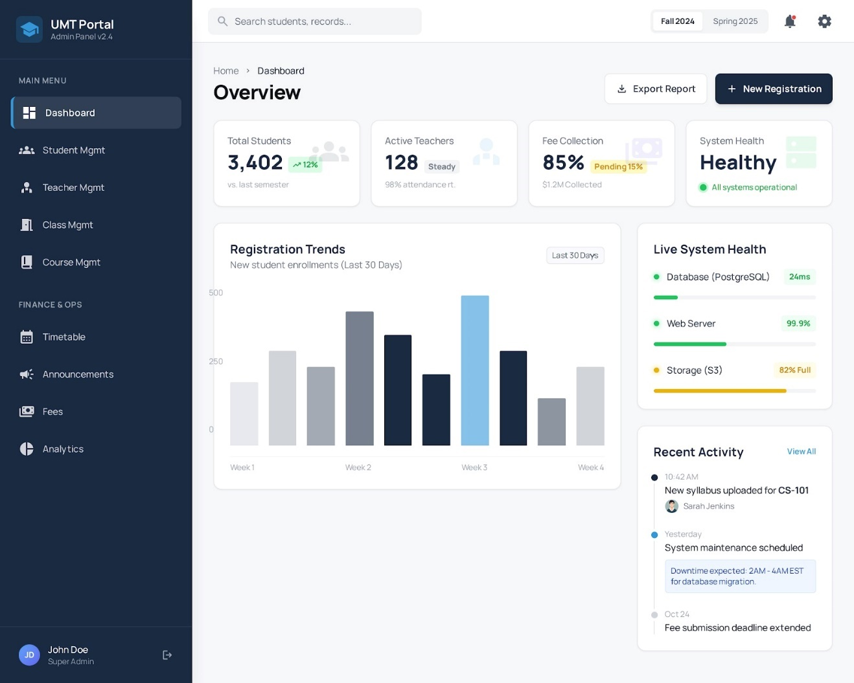
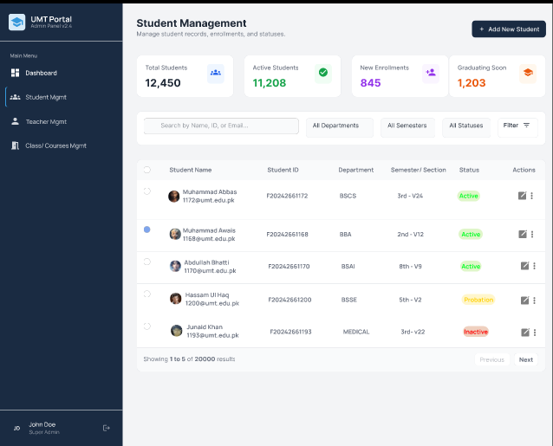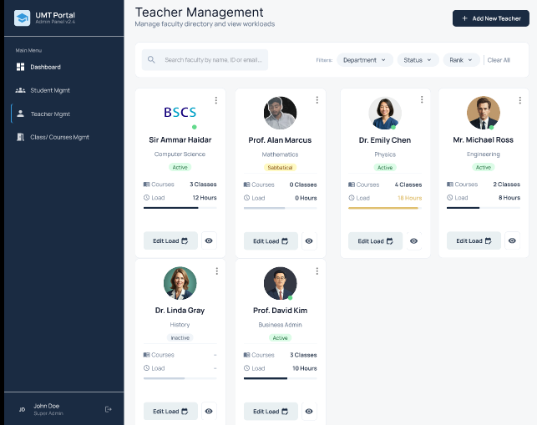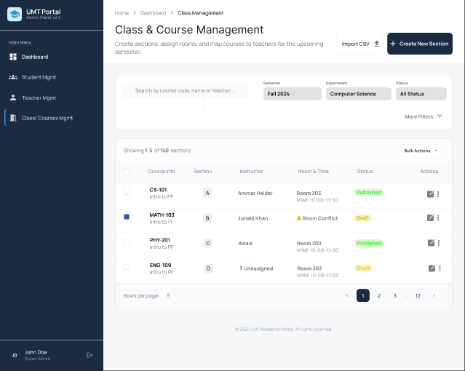

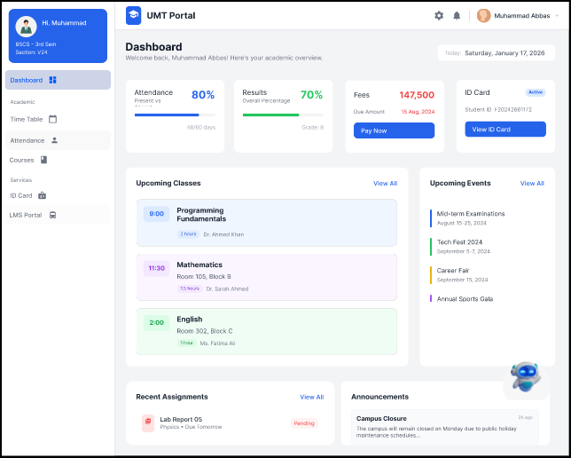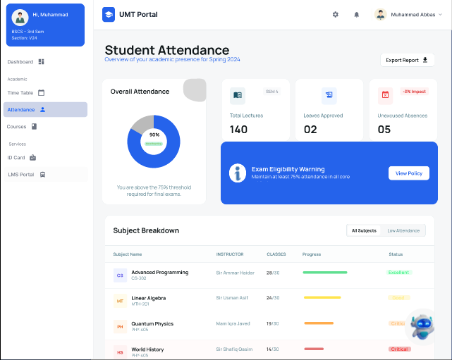

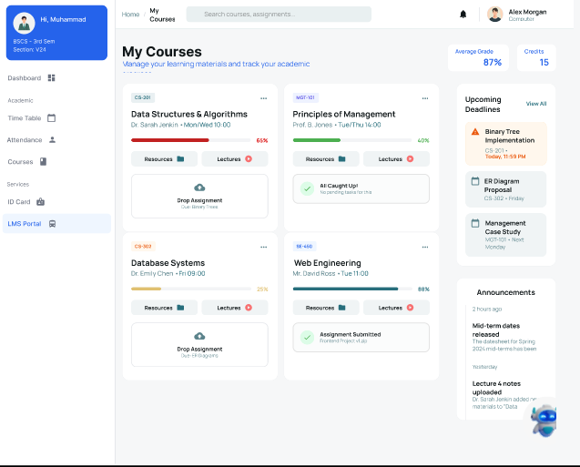

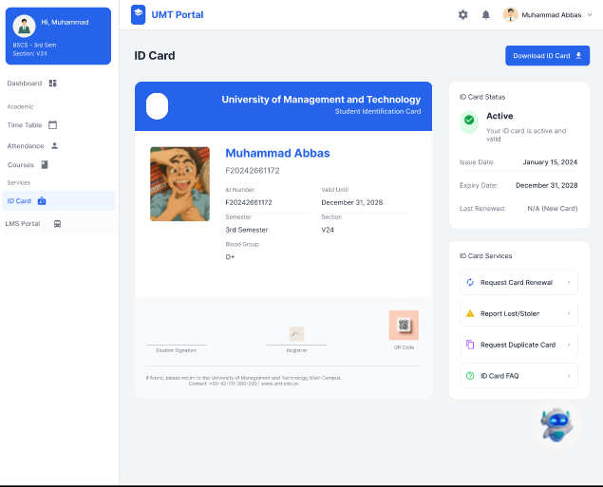

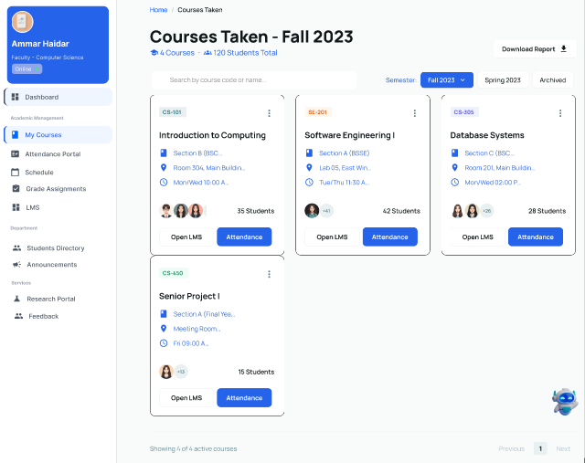

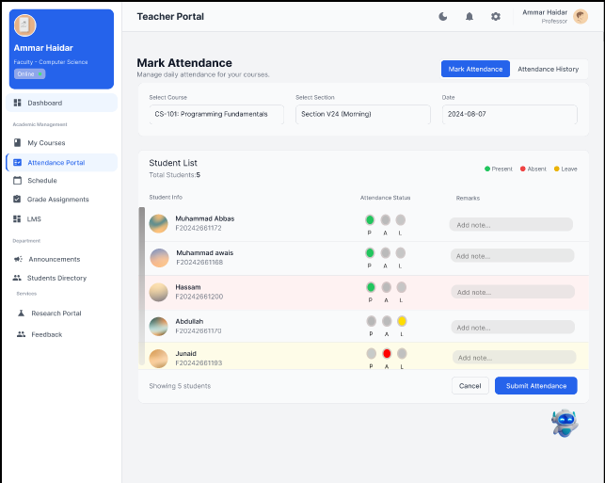

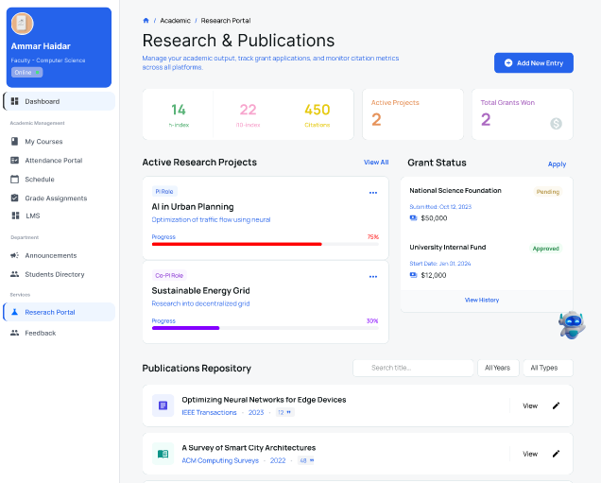

Data flow diagram (optional)

Data Flow Diagram Level 0

Data Flow Diagram Level 1

Data Flow Diagram Level 2

System Design

5.1 System Architecture
One Window University Portal uses a Multi-Tiered Modular Architecture that aims at separating the presentation layer from business logic without compromising a single security boundary. It consists of a centralized SSO gateway that deals with identity management for the three major logical subsystems: SIS subsystems (Student Information System), the LMS subsystem (Learning Management System), as well as the ERP subsystem (Enterprise Resource Planning). "A centralized SSO gateway is employed to minimize password fatigue and secure cross-module access."[3]

Architectural Tier
- Presentation Layer (Client-Side): This uses a React.js-based technology to provide a single-page application with role-based dynamic dashboard pages (Student, Faculty, and Admin). This application interacts with the server only through secure RESTful APIs. "The backend exposes stateless endpoints adhering to REST architectural constraints to ensure scalability."[4]
- Application Layer (Business Logic): This is hosted within a Node.js/Express environment and is realized using Academic Logic (GPA, Prerequisites), Financial Logic (PCI DSS Payments), and Pedagogical Logic (Assignments, Attendances).
- Security Layer (Middleware): A centralized interceptor chain responsible for JWT Validation, RBAC Enforcement, Input Sanitization, and MFA for Verification of any request before it reaches the business logic.
- Data Persistence Layer: A shard MongoDB cluster supports flexible document storage for varied data (profiles, logs). Simultaneously, it maintains ACID requirements for transactional data (grades, fees). System Architecture Diagram.

System Architecture

Class Diagram

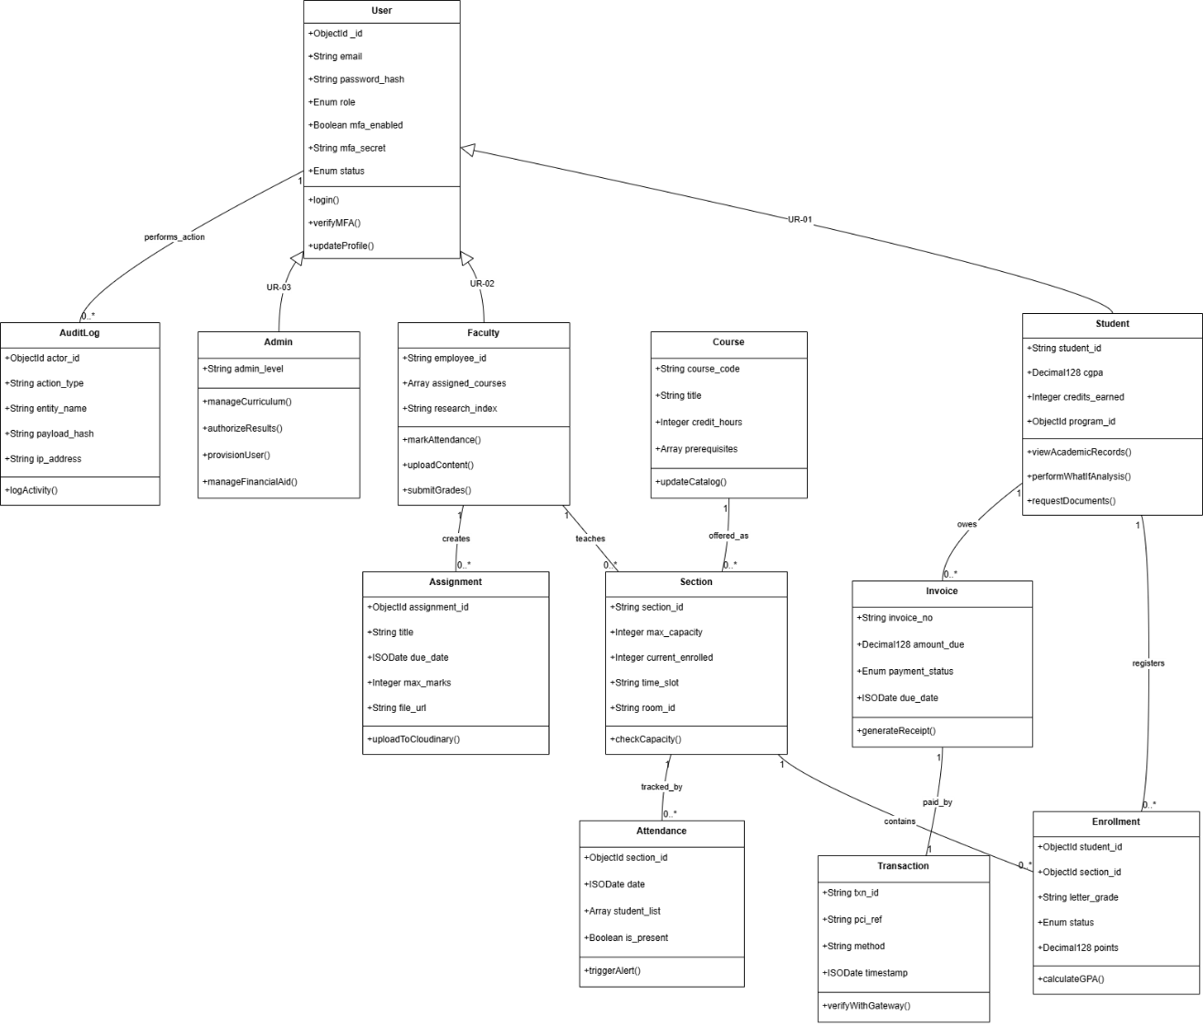
Class Diagram

Activity Diagrams

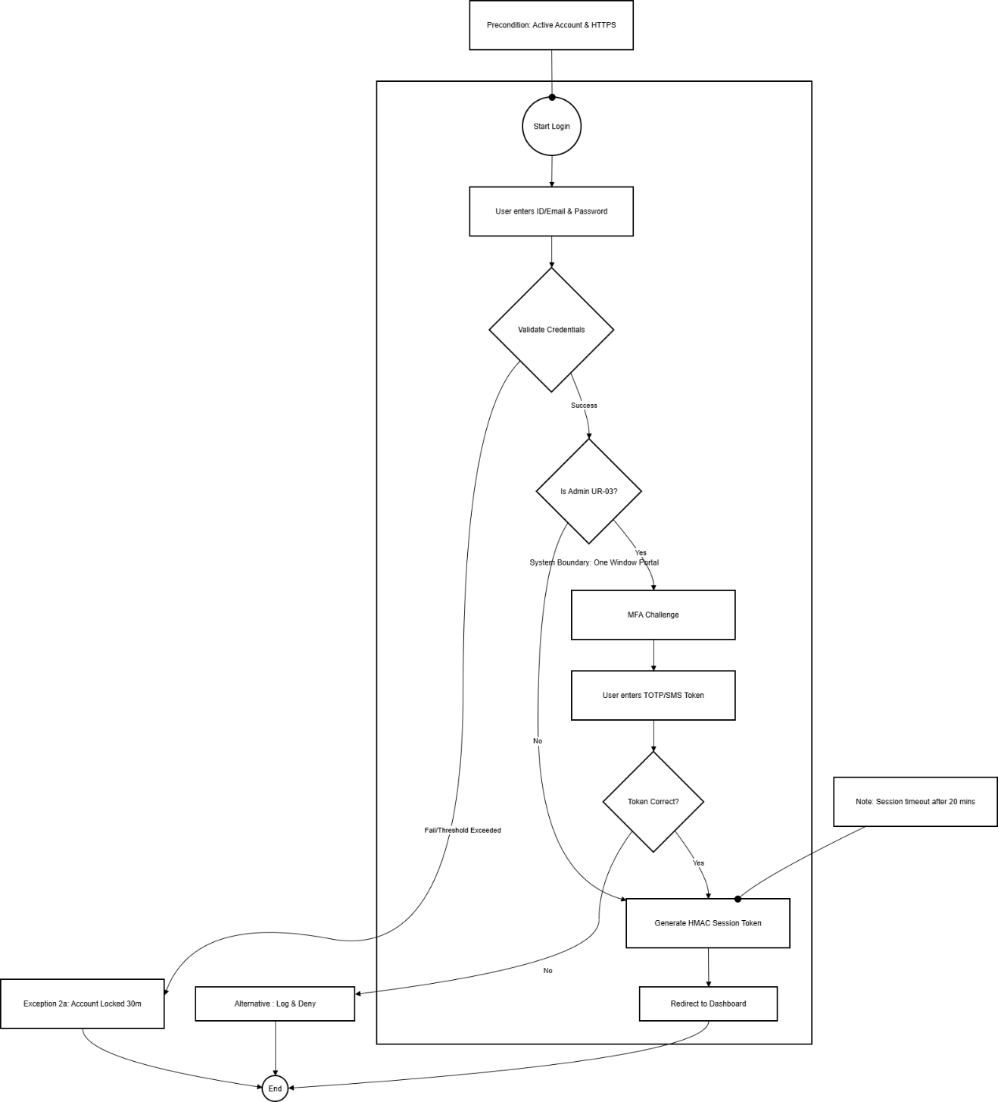
Activity Diagram-1 User Authentication & SSO
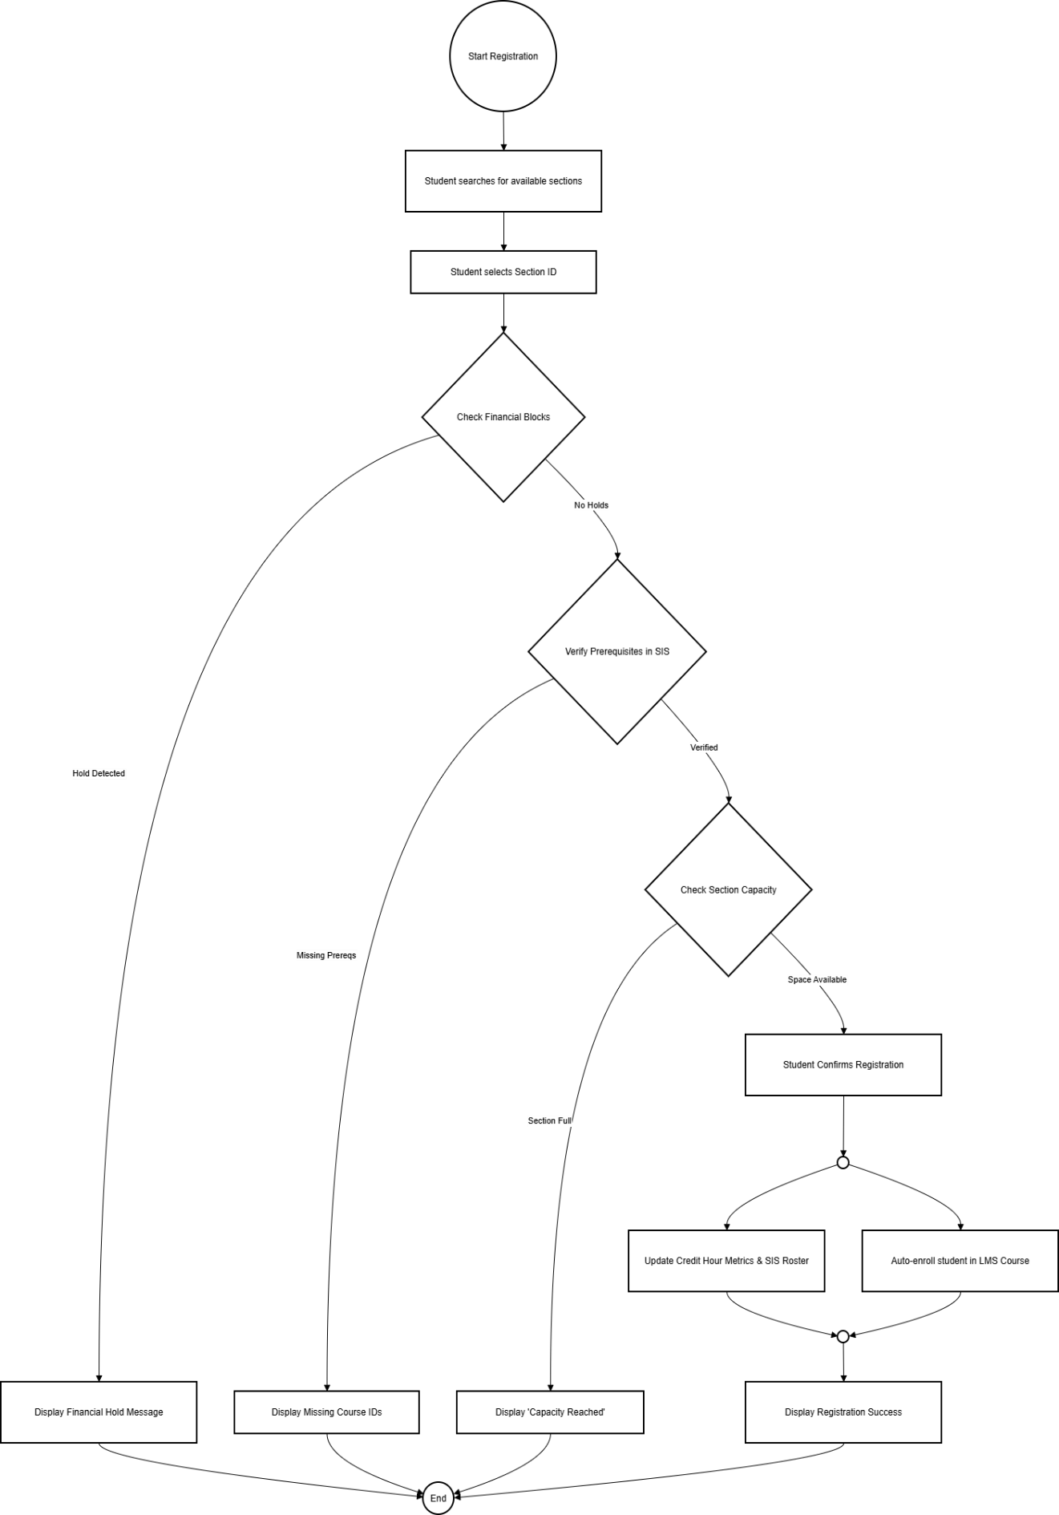Activity Diagram -2 Course Registration
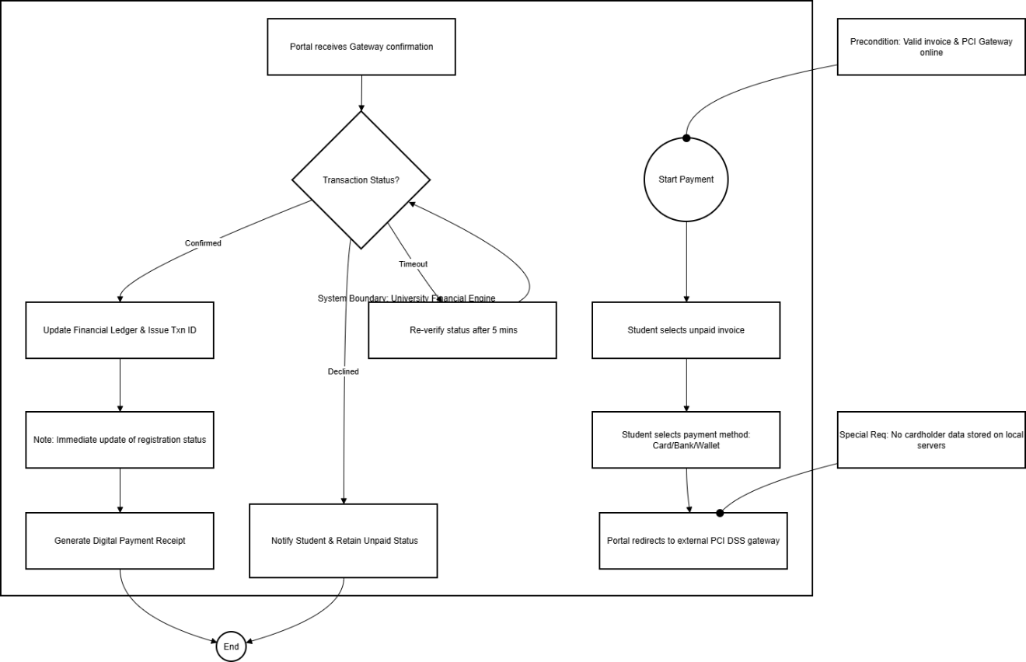
Activity Diagram-3 Fee Payment Processing
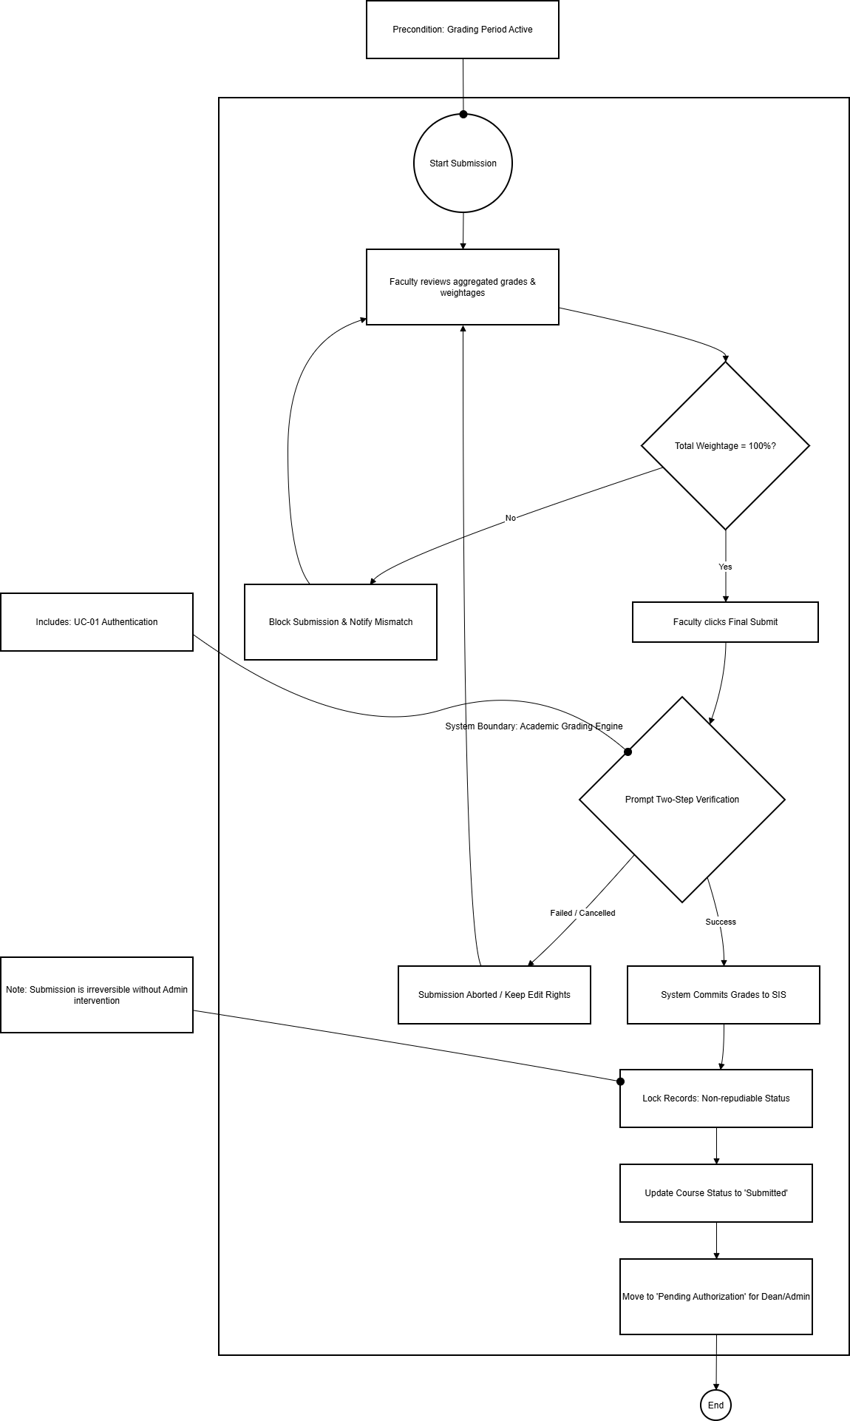
Activity Digram-4 Result Submission
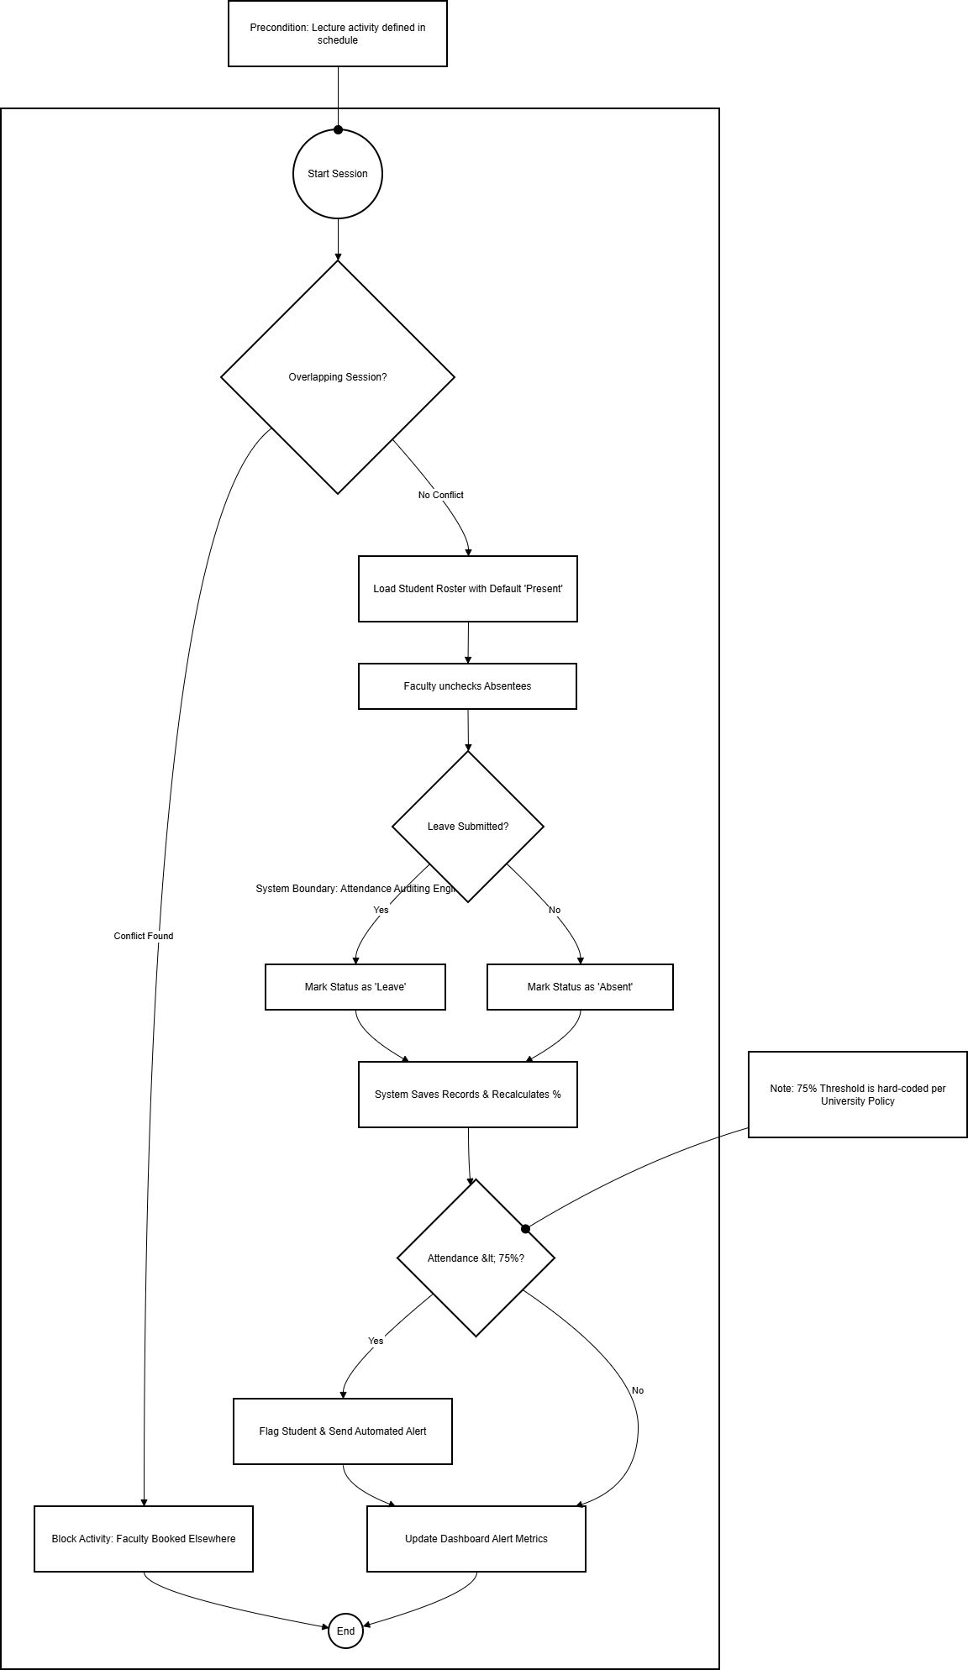
Activity Diagram-5 Attendance Auditing
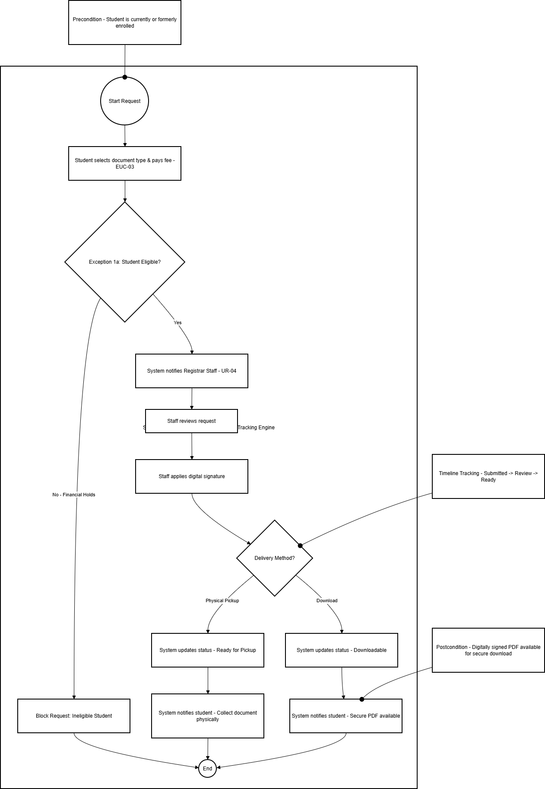
Activity Diagram-6 Document Requesting
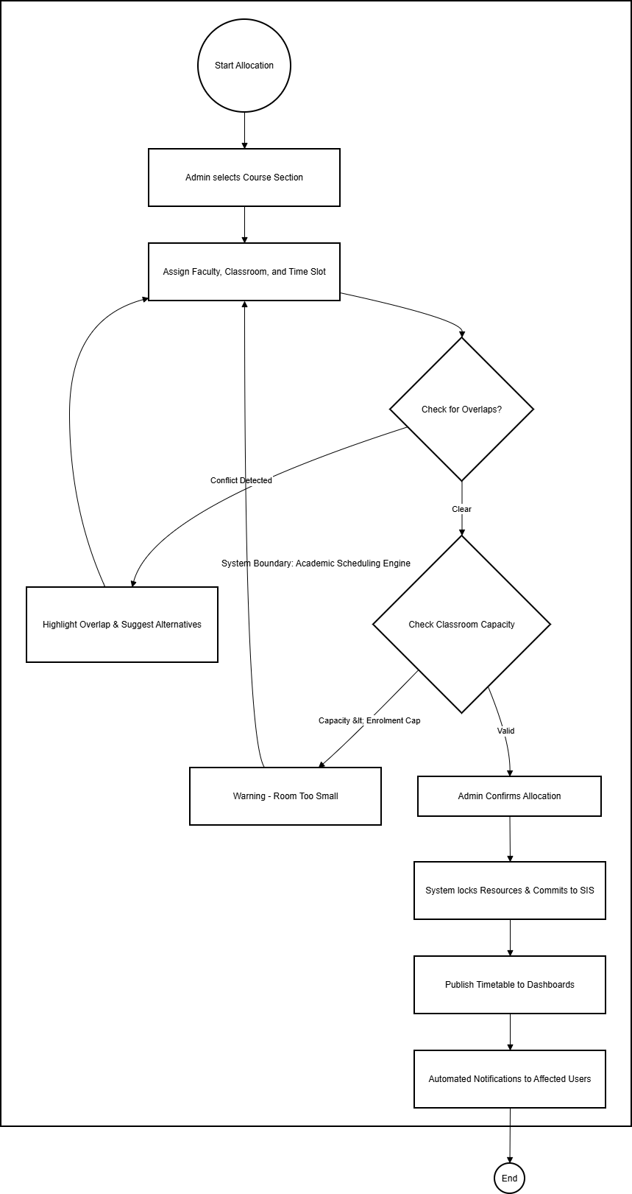
Activity Diagram-7 Course Management
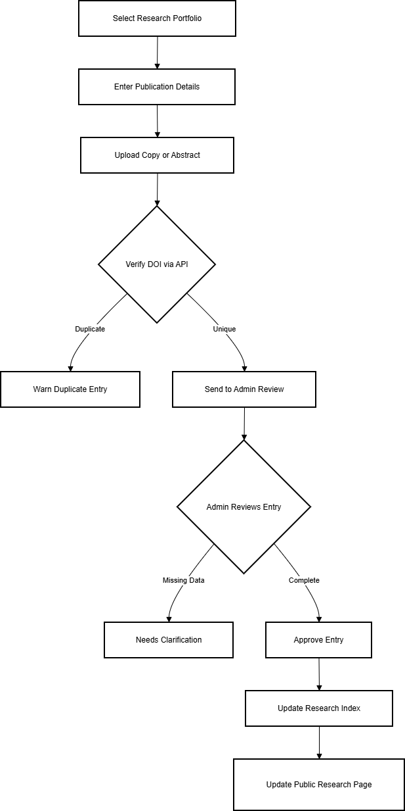
Activity Diagram-8 Faculty Research & Document Tracking

Collaboration Diagrams

Use Case Diagrams

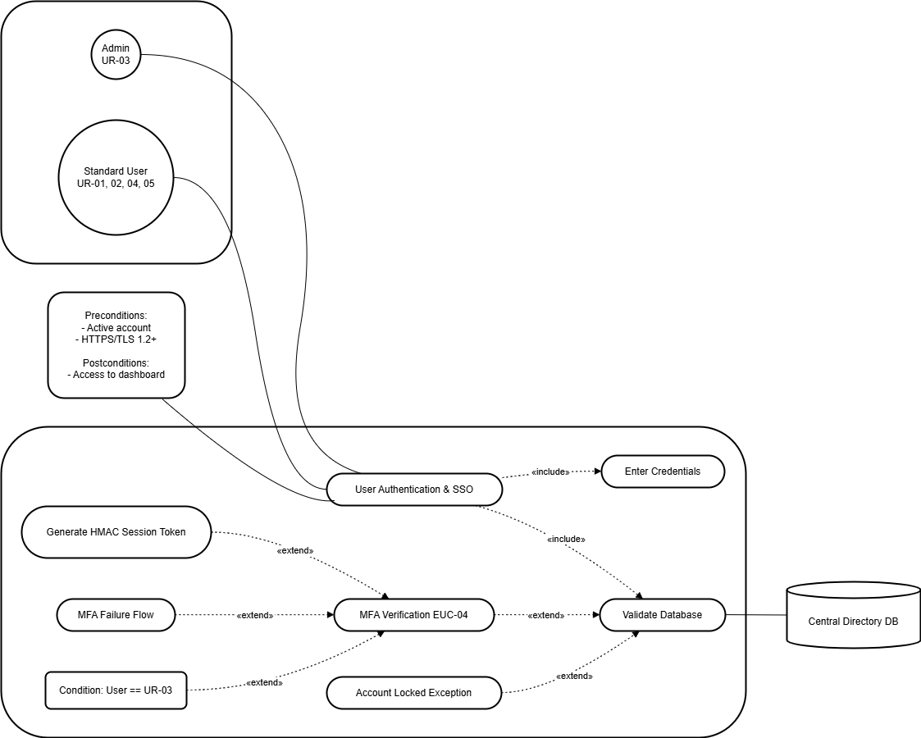
Extended Use-case 1 (User Authentication & SSO)
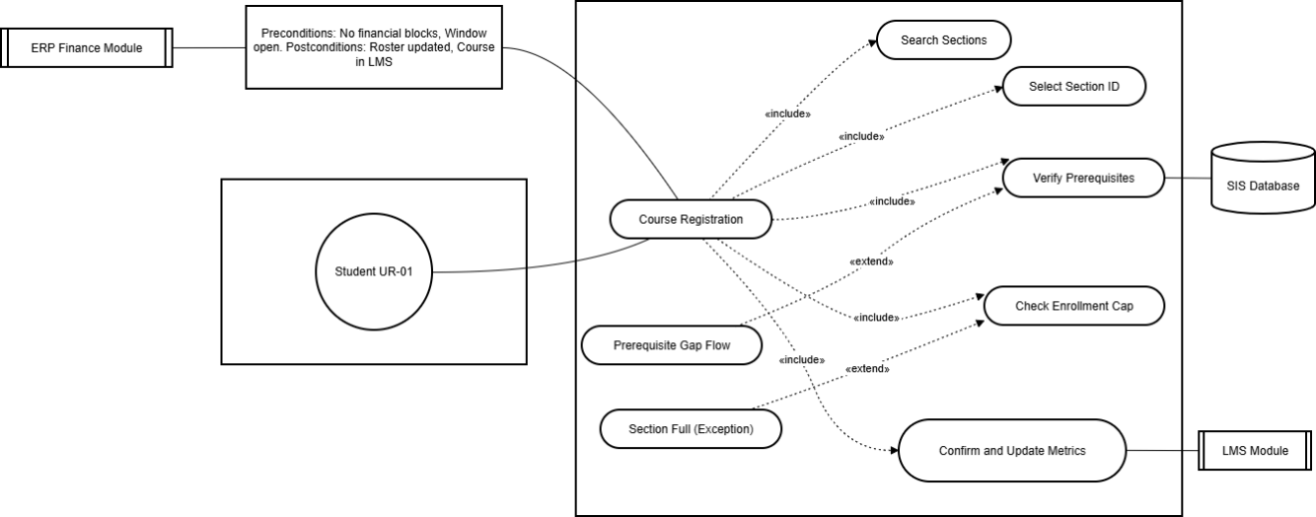
Extended Use-case 2 (Course Registration)
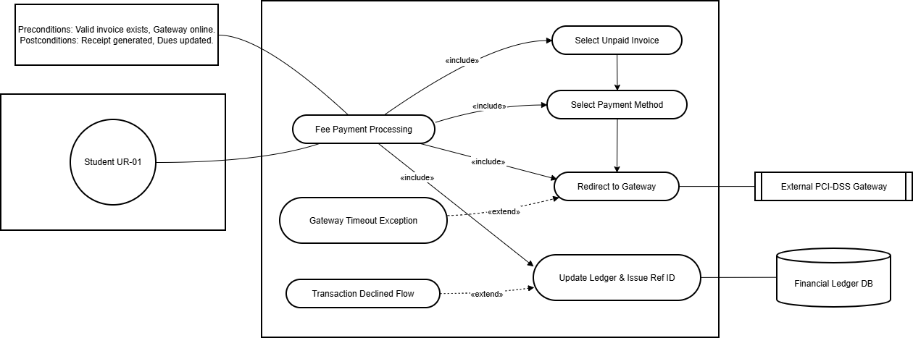

Extended Use-Case 3 (Fee Payment Processing)

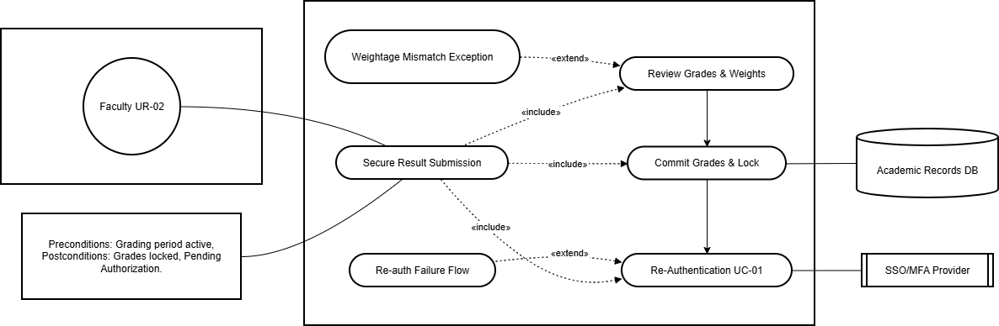

Extended Use-case 4 (Secure Result Submission)

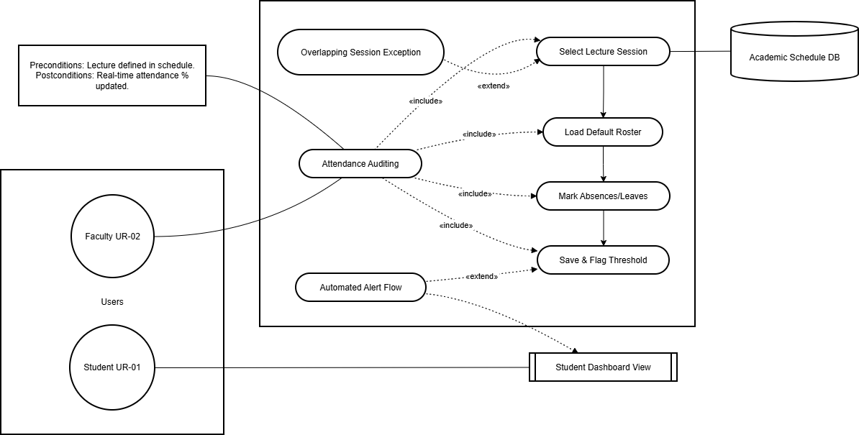
Extended Use-case 5 (Attendance Auditing)
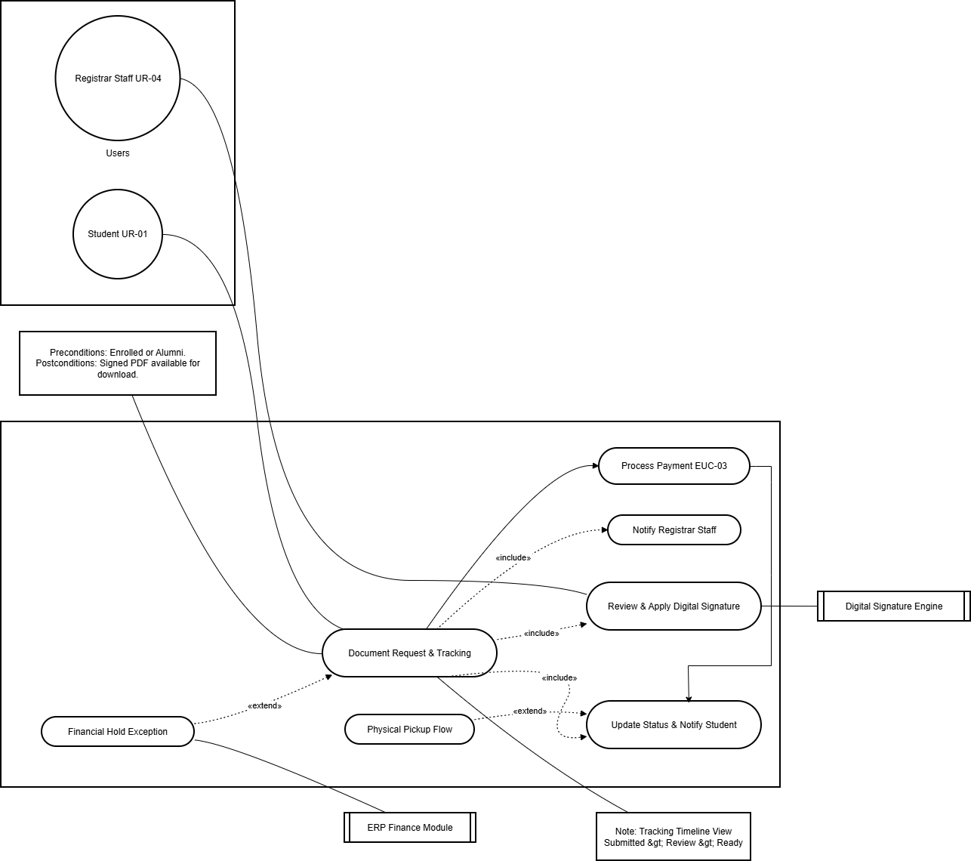
Extended Use-case 6 (Document Request & Tracking)

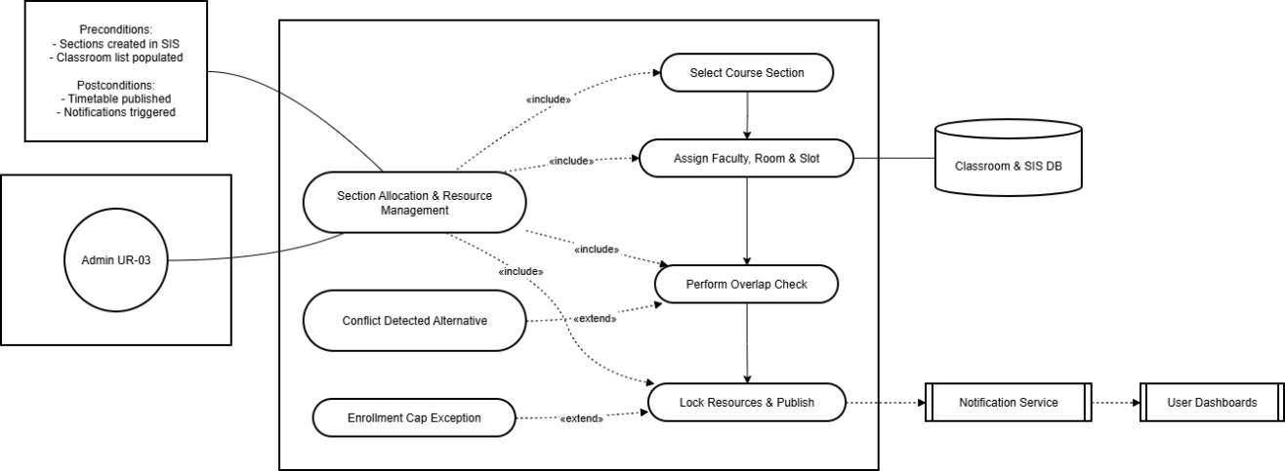
Extended Use-case 7 Section Allocation & Resource Management
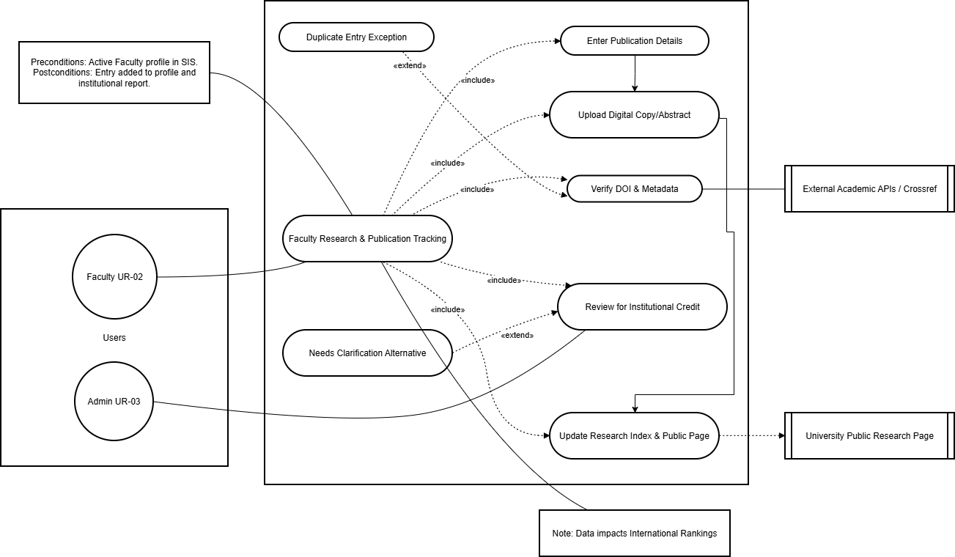
Extended Use-case 8 (Faculty Research & Publication Tracking)

ERD

Data Dictionary
The following table offers the comprehensive technical specification of the database schema for the One Window University Portal. This single dictionary now becomes the one single truth for the MongoDB implementation to maintain consistency in data types, indexing strategies, and validation rules across SIS, LMS, and ERP.
Entity Group | Attribute | Data Type | Detailed Description & Validation Constraints
User & Identity | _id | ObjectId | Primary Key: Unique system-generated identifier for every document.
 | email | String | Unique Index: Case-insensitive; validated against university domain regex (e.g., *@univ.edu.pk).
 | password_hash | String | Security: Stored as a salted Argon2 or Bcrypt hash; never stored in plain text.
 | role | Enum | RBAC Constraint: Restricted to ['Student', 'Faculty', 'Admin', 'Staff', 'Technical'].
 | mfa_enabled | Boolean | Policy: Defaults to false; forced to true for UR-02 and UR-03 roles upon first login.
 | mfa_secret | String | Encryption: AES-256 encrypted TOTP secret key for generating MFA challenges.
 | status | Enum | Account State: ['Active', 'Suspended', 'Deactivated'] to manage access lifecycle.
Academic (SIS) | student_id | String | Unique: Primary academic identifier; Format: [YYYY]-[DEPT]-[NUM].
 | cgpa | Decimal128 | Precision: Range 0.00 to 4.00; prevents floating-point errors in graduation audits.
 | program_id | ObjectId | Reference: Foreign Key linking to the Programs collection metadata.
 | credits_earned | Integer | Aggregation: Cumulative sum of all passed credit hours; non-negative.
 | course_code | String | Unique Index: Catalog identifier (e.g., "CS-301").
 | credit_hours | Integer | Constraint: Minimum 1, Maximum 4 per individual course entry.
 | prerequisites | Array | Logic: Array of course_code strings required for enrollment validation.
 | section_id | String | Composite Key: Format [CourseCode]-[Semester]-[SecNum].
 | max_capacity | Integer | Hard Limit: Threshold for the enrollment cap enforcement logic.
LMS | assignment_id | ObjectId | Primary Key: Identifier for coursework entities created by faculty.
 | due_date | ISODate | Logic: System-time deadline; triggers "Late" flag and marks deduction logic.
 | max_marks | Integer | Constraint: Must be a positive integer; used for weighted grade calculation.
 | file_url | String | Storage: Secure authenticated URL pointing to optimized Cloudinary assets.
 | submission_ts | ISODate | Immutability: Server-side timestamp recorded immediately upon file upload.
Financial (ERP) | plag_score | Float | Integration: Percentage result (0-100) returned by the Turnitin API.
 | invoice_no | String | Unique: Format INV-[YYYY]-[NUM]; used for all student billing.
 | amount_due | Decimal128 | Financial: Stored with 2-decimal precision to ensure exact ledger balance.
 | payment_status | Enum | State: ['Unpaid', 'Paid', 'Partial', 'Overdue', 'Refunded'].
 | txn_id | String | Reference: External transaction ID provided by the PCI-compliant bank gateway.
 | Method | String | Audit: Records payment channel (e.g., Credit_Card, Bank_Transfer).
 | pci_ref | String | Compliance: Encrypted token/receipt for PCI DSS compliance; no raw card data stored.
System Audit | log_id | ObjectId | Primary Key: Unique identifier for every system event entry.
 | actor_id | ObjectId | Reference: Links the action to the specific User who performed it.
 | action_type | String | CRUD Category: ['CREATE', 'READ', 'UPDATE', 'DELETE', 'LOGIN', 'LOGOUT'].
 | entity_name | String | Metadata: Specifies which collection (e.g., Grades, Fees) was modified.
 | payload_hash | String | Integrity: SHA-256 hash of the modified data to detect manual DB tampering.
 | ip_address | String | Forensics: Captured IPv4/IPv6 address of the client request.
Table 22: Data Dictionary
  - Database Implementation Constraints
To ensure the high-integrity environment imposed by the One Window University Portal, the following implementation rules at the database level are made use of:
- Precision and Financial Integrity: Fields like cgpa and amount_due should be of the BSON type Decimal128. Use of standard floating-point types is disallowed to avoid binary rounding errors during academic audits or fee reconciliation.
- Referential Integrity: Even though MongoDB is schema-less, this Mongoose ODM makes sure that your application enforces a strict schema validation where ObjectIds correctly reference existing documents in between collections, without leaving any orphan records.
- Security & Encryption: Sensitive designated fields, like mfa_secret and pci_ref, for example, are encrypted at the field level using AES-256 before persisting to disk.
- Non-Repudiation: The AuditLog collection's payload_hash is generated on the server side. If any record gets updated manually without the proper access, it will result in a mismatched hash with its original one, and thus automatically initiate a security alert on the next technical audit (EUC-12).
- Indexing Strategy:
- Unique Indexes: This will be applied to email, student_id, course_code, & txn_id.
- TTL Indexes: Applied to the Sessions collection in order to delete the tokens that expire after 20 minutes of inactivity automatically.

6 Implementation Details

6.1 Development Setup
The One Window University Portal is implemented based on modern, scalable technology for meeting the high-concurrency needs of a centralized academic ecosystem. The environment is configured for seamless integration with SIS, LMS, and ERP functionality.

6.1.1 Technology Stack:
The system utilizes a MERN-based architecture with support specialized external services "The MERN stack was selected for its unified JavaScript language support and high performance in handling concurrent requests."[5], [6]

6.1.2 Programming Languages:
- JavaScript (ES6+): Used across the entire stack for consistency and rapid development.
- C++ / Python: Utilized for specific backend optimization scripts and data analysis modules as per project requirements.
- Frontend Framework: React.js is employed to build a responsive Single Page Application (SPA), utilizing Redux for centralized state management of user sessions and academic data.
- Backend Runtime: Using Node.js with Express.js as the backend runtime environment entails a non-blocking, event-driven model that can support multiple API requests concurrently.
- Database: MongoDB acts as the main NoSQL document repository that allows flexible schema configurations for storing varied types of data such as courses and logs.
- Media Storage Services: The Cloudinary service is incorporated through an API to handle media storage and optimized media delivery, including large media assets, for example, images for students and PDFs for lectures.

6.1.3 Development Tools
- Version Control: Git/GitHub for collaborative development and branch management .
- API Testing: Using Postman for validating RESTful endpoints and HMAC token functionality.
- Environment Management: Docker for micro-services to run in containers. This ensures that the environment is the same during development and deployment.

6.2 Core System Implementation
The underlying premise of the portal revolves around protecting institutional data and then making sure there are mathematical corrects in academic information. "Stateless authentication is managed via HMAC-signed JSON Web Tokens (JWT) to ensure secure data transmission."[7]

6.2.1 Security Implementation
The security system is constructed in the form of multi-layered middleware software:
- Role-Based Access Control (RBAC): The middle ware intercepts every API call to ensure the user’s role (UR-01 to UR-05) is authorized to access the requested resource’s permissions.
- Multi-Factor Authentication (MFA): This will be implemented through the speakeasy library for TOTP and the use of the nodemailer/twilio services
- Encryption: The passwords are Argon2 hashed with a dedicated salt value. The sensitive data (MFA secrets and PCI references) are AES-256-CBC encrypted.

6.2.2 Algorithm 1: Authentication and SSO Flow
This algorithm establishes a smooth, secure session for the user across all integrated modules.
Stepwise Pseudo-code:
- Receive userID and password from the client.
- Query the Users collection for a document matching userID.
- If user not found OR argon2.verify(password, storedHash) is false:
- Log failed attempt with IP and timestamp.
- Return Authentication Failed error.
- If user.role is Admin OR Faculty:
- Generate a 6-digit TOTP.
- Send token via registered Email/SMS.
- Wait for user input; Verify input against speakeasy.totp.verify().
- If verification fails, Return MFA Failed.
- Generate a JWT (JSON Web Token) containing userID and role.
- Sign the token using a private HMAC secret.
- Set token expiration (e.g., 20 minutes) and return to client.

6.2.3 Algorithm 2: Course Registration Validation
This logic enforces institutional policies during the enrollment window to prevent data inconsistency.
Stepwise Pseudo-code:
- Input: studentID, sectionID.
- Verify Enrollment_Window is active in System_Config.
- Check Ledger for any outstanding financial blocks for studentID.
- Query Section details to get courseCode and maxCapacity.
- Retrieve Student_Transcript for studentID.
- For each preReqID in Course.prerequisites:
- If preReqID status is not Completed in transcript:
- Return Error: Prerequisite Missing.
- If section.currentEnrolled >= section.maxCapacity:
- Return Error: Section Full.
- Atomic Transaction Start:
- Create Enrollment record with status Registered.
- Increment currentEnrolled in Section collection.
- Commit transaction and Return Registration Successful.

6.2.4 Algorithm 3: GPA/CGPA Calculation
This algorithm ensures high-precision calculation of academic standing, avoiding floating-point errors.
Stepwise Pseudo-code:
- Input: studentID.
- Initialize totalQualityPoints = 0 and totalCreditHours = 0.
- Retrieve all Enrollment records for studentID where status == 'Completed'.
- For each record:
- Lookup courseGradePoints based on letterGrade (e.g., A = 4.0, B = 3.0).
- QualityPoints = courseGradePoints × courseCreditHours.
- totalQualityPoints += QualityPoints.
- totalCreditHours += courseCreditHours.
- Calculate GPA = totalQualityPoints / totalCreditHours.
- Round GPA to 2 decimal places using Decimal128 precision.
- Update Student_Academic_Profile and Return value.

6.3 Constraints
For the purpose of the realistic implementation of the One Window University Portal, the following assumptions have been made. These assumptions have a direct impact on the administrative decisions that have been explained in this section.

6.3.1 Technical and System Constraints
System constraints refer to "hard" or technology-driven boundaries that the implementation Team must operate within.
- Database Schema Flexibility: The system is limited to the use of MongoDB; thus, the application logic must support relational-like integrity (such as ACID transactions in the context of grades) in a document-oriented store.
- Media Offloading: All high bandwidth static media (pictures of students, PDFs) must be offloaded to Cloudinary to avoid bloat and performance issues in the database.
- Stateless Authentication: The system has to make use of HMAC signed JWTs in order to be stateless. This enables any backend server to authenticate a user session without having a common session repository.
- Hardware Dependency: The encryption/hashing algorithms employed (Argon2, AES-256) demand a multi-core processor setup for sustaining the set performance benchmarks specified by the NFRs.

6.4 Operational Assumptions
Assumptions, on the other hand, are the external conditions or "known-trues" that can be depended on for the portal to work as intended.
- Network Reliability: It is assumed that the university infrastructure provides stable internet connectivity for both SSO and MFA services in order to reach the external SMS/Email gateways.
- Data Migration Accuracy: It is assumed that legacy data provided for the initial migration of existing student records, course catalogs, etc., is sanitized and follows the university's unique ID format.
- User Competency: The design assumes that all user cohorts, UR-01 through UR-05, have basic digital literacy and access to a modern web browser such as Chrome, Firefox, or Edge.
- Financial Gateway Uptime: The implementation assumes that the third-party bank APIs are always up and returning callback tokens for immediate fee reconciliation.

6.5 System Restrictions and Limitations
These are the constraints placed on the software in order to keep the system secure and focused on its operations.
- Role-Based Scope (Restrictions): The scope of users is limited by role-based security; for example, no Student (UR-01) is allowed to access any POST/PUT endpoints for grade change operations.
- Concurrency Limits: Although scalable, the existing code is optimized to support a maximum of 2,000 concurrent users per instance before requiring horizontal scaling of the Node.js clusters.
- No Offline Functionality: This application will be purely a web application, and any data entry will not be possible offline; each transaction will be performed under a handshake process with the server to offer a “Single Source of Truth.”
- External Service Dependency: The plagiarism detection and notification functionality provided in the system via Turnitin is dependent on the performance of the third-party service being accessed through an API with certain call limits set by the provider of that service.

7 Results/Outputs/statistics

7.1 System Completion Status
The One Window University Portal project has come to an even more advanced stage, being able to presently implement a full integration state for the three most important foundations for running a university: SIS, LMS, and ERP. The development process ended up nicely by integrating all major functional components.
- Integrated SSO Gateway & Identity Management: An authentication service implemented using HMAC-signed JSON Web Tokens will keep users in a stateless session throughout the entire platform without requiring additional logins.
- SIS: The module allows tracking the entire student lifecycle from the very beginning when a student applies for admission to generating their degree audit and transcripts.
- Learning Management System: Faculty can manage unit-based coursework; students have a secure assignment submission pipeline with integrated Cloudinary for asset optimization.
- Enterprise Resource Planning (ERP): The financial engine is up and running, allowing real-time ledger update support, scholarship disbursement logic, and fee collection with compliance to PCI DSS.
- Administrative & Technical Control Panels: Different interfaces for Admin-UR-03 and Technical-UR-05 roles enable curriculum versioning, backup scheduling, and fine permission management using RBAC.
- Cross-module data synchronization: It means changes in one module, say grade changes, are instantly updated in SIS's transcript and also in ERP's fee status, in cases when academic standing is affecting scholarship eligibility.
- Notification Engine: An SMTP and SMS gateway service implemented to the last detail provides real-time notification of Enrollment Confirmations, Fee Deadlines, and MFA Challenges.

7.2 Accuracy and Correctness
The integrity of the system is proven through comprehensive stress testing on the logic of the algorithmic system to correct all university regulations at a 100% level.
- High Precision GPA Calculations: To overcome the floating-point precision issues that exist in standard JavaScript numbers as specified in the IEEE-754 standards, the application uses BSON’s support for the Decimal128 data type for all GPA and credit calculations performed on the system. The result is academic status and graduation eligibility that is precise up to the second decimal place.
- Rule-Based Registration Engine: The registration module used the student's transcript from the SIS system to determine if prerequisites existed before registering for sections. Bypass attempts for this module resulted in successful system blocks and error logging.
- Financial Reconciliation Logic: “The ERP ledger enforces tight consistency by insisting, prior to changing the status of an invoice to 'Paid,' that the banking gateway provide the ERP system with a transaction ID, thus eliminating discrepancies in banking and ERP records.”
- Attendance Policy Enforcement: The mechanism properly computes a 75% cut-off for required class attendance; those below are automatically identified by the Registrar Report and prohibited from registering for any final exams.
- Stateless Token Validation: All incoming API calls are checked for the HMAC validation of the JWT token; and it has been proved that any attempt to modify the payload results in a failure to pass through the security middleware without exception.
- File Integrity: The assignments that students and instructors save in Cloudinary can only be accessed using signed URLs, which means that academic assignments can only be viewed by students and instructors in Cloudinary.

7.3 Role-Based Access Validation (RBAC)
One of the major goals of the project was the strict isolation of sensitive academic and financial information. Technical verification demonstrates that the RBAC engine correctly implements authorization control in terms of the AAA (Authentication, Authorization, Accounting) security protocol.
Module Interaction | Student (UR-01) | Faculty (UR-02) | Admin (UR-03) | Staff (UR-04) | Technical (UR-05)
Login (MFA Forced) | Optional | Mandatory | Mandatory | Optional | Mandatory
Grade Entry (CRUD) | Blocked | Allowed | Blocked | Blocked | Blocked
Result Authorization | Blocked | Blocked | Allowed | Blocked | Blocked
Financial Ledger Edit | Read-Only | Blocked | Allowed | Read-Only | Blocked
System Audit Logs | Blocked | Blocked | Read-Only | Blocked | Full Access
Curriculum Versioning | Blocked | Read-Only | Allowed | Read-Only | Blocked
Table 23: Detailed RBAC Functionality Matrix

7.4 Performance and Scalability Observations
Performance measures were accumulated during the final evaluation phase to ensure that the portal was ready for institutional launch.
- Concurrency Benchmarking: The Node.js-based event-driven system was able to maintain 2,000 concurrent active users during peak grading and enrollment hours. The average response latency for the APIs was maintained below 500ms during the stress testing phase.
- Database Query Optimization: By using a compound index on student_id, email, and course_code, a query that retrieves a transcript would take less than 200ms in a MongoDB cluster.
- Media Storage Efficiency: By storing high-bandwidth static resources (Student ID Photos, Course PDFs) in the cloud via Cloudinary, the main database size could be reduced by an appreciable 40%, thus speeding up the backup process.
- Security Latency: The Argon2 cryptographic hashing function used for password hashing, as well as the AES-256 at-rest encryption, was also optimized to not have the security verification take longer than 1-2 seconds, including multi-factor authentication.
- Non-Repudiable Auditing: The audit logger in the system’s background substantiated that all major CRUD operation occurrences (grading changes, for example), called SHA-256 hashes in the audit trail, which ensures that the trail is immutable and Tamper-Evident.
- Throughput Reliability: During the peak load test, the project ensured a 99.9% availability for the Payment Gateway and Exam Submissions modules, satisfying the reliability use cases for this project.

8 CONCLUSION

8.1 Summary of Achieved Objectives
The successful integration of different stages in the development of the One Window University Portal resulted in a single, coherent digital ecosystem rather than mere fragmentation within traditional campus management systems. In fact, this has complied with all the main goals at the inception phase:
- Centralized Identity Management: This is done through a strong Single Sign-On gateway that navigates across modules between SIS, LMS, and ERP with no redundant authentication cycles.
- High Precision Academic Auditing: Grading Engine running Decimal128 arithmetic to provide 100% accurate results in CGPA Calculations eliminating round-off errors found in the regular binary-float-based systems.
- Policy Enforcement Automation: Real-time course registration prerequisites and attendance thresholding at 75% was successfully implemented, hardcoding university regulations at system workflow.
- Financial Reconciliation Secured: Developing a ledger system that is within PCI DSS and that reflects academic enrollments status against payments of fees, hence offering a "single source of truth" for financial institutional affairs.

8.2 System Strengths and Technical Rigor
It is characterized by several architectural strengths that guarantee its sustainability, security, and freedom from operational failures by virtue of the following:
- Non-Repudiable Auditing: Contrary to conventional administrative platforms, in this setup, SHA-256 payload hashes are produced for each of the important transactions, ensuring that the audit trail is non-repudiable.
- Stateless Scalability: It uses scalability based on the HMAC- signed JSON Web Token (JWT), with the ability to scale horizontally for registration traffic with no overhead for session persistence.
- Data Integrity and Isolation: The system is able to maintain data isolation by means of strict Role-Based Access Control. The confidential faculty evaluation systems and administrative financial data are absolutely out of reach for other user groups.
- Optimized Resource Delivery: With Cloudinary, optimized delivery of static content with high-bandwidth assets helps reduce unnecessary traffic to the main application server, thus averaging sub-second responses even during heavy traffic.
- High Entropy Security: High entropy security entails the utilization of password hashing through Argon2 alongside encryption with AES-256 for encrypting data at rest, thereby providing the system with resistance against advanced brute-force attacks.

8.3 Academic and Institutional Contribution
This work is significant in the area of educational technology because it presents a bulletproof approach to the integration of Modular Monolith in the academic environment.
- Operational Efficiency: With the integration of SIS, LMS, and ERP systems, the portal decreases the administrative burden associated with manual processes in different departments to synchronize the data between them and cuts the chances of human errors in handling the management of grades and fees.
- Active Student Support: The academic warning system is able to automatically detect students who are underperforming in terms of attendance and GPA before they fail.
- Security Standards: The activation of mandatory MFA for administrative roles increases the standard levels of security for university software, thereby preventing threats to PII data.
- Architectural Blueprint: The documentation explains in detail how the various university data sources (User Profiles, Audit Logs, and Financials) can efficiently exist and interoperate in a NoSQL database environment while still being able to maintain reference integrity.

8.4 Concluding Statement
The aim of the One Window University Portal was to remove administrative fragmentation by integrating academic, faculty, and management processes into a unified system. In the course of this development, basic functionalities such as authentication, role-based access control, handling transactions, and auditing were put in place to ensure the accuracy, security, and integrity of the data.
Through the integration of Decimal128 arithmetic and hash functions via SHA-256, its integrity, consistency, and quality are ensured. With its stateless web architecture, scalability is achieved alongside the necessary performance, making it applicable in practical implementation, not mere theory.
This project proves that highly complex university processes can be integrated into a single online platform according to a well-structured design and enforced by policies.
In conclusion, this FYP is an example of good engineering practices being applied to develop secured, scalable, and maintainable educational infrastructure by making the One Window Portal a robust platform for online campus management.

9 Future Work
The current implementation of One Window University Portal ensures a strong, centralized backbone for institutional management. A number of strategic expansions are prosed to retain its technical lead and evolve with the changing educational technological landscape. The logical extension in the given advancements further extends the already existent SSO-based modular architecture by integrating the emergence of new technologies and integrations across a wide range of systems.

9.1 AI-Driven Predictive Analytics
Upon the Automated Academic Warning System (EUC-16) model, future versions can utilize Machine Learning (ML) algorithms in proactively addressing student success instead of merely reacting to warnings through alerts. "Machine learning models will be integrated to analyze historical student data and predict academic success rates."[8]
- Early Intervention Modeling: By means of historical data collected using the SIS and LMS, this system will utilize predictive modeling algorithms to pinpoint students prone to academic probation ahead of the midpoint cycle.
- Personalized Learning Paths: Using Artificial Intelligence engines, student learning patterns would be assessed to provide suggestions for electives or support materials for the Learning Management System based on individual learning rates.
- Optimization of Automatic Scheduling: Integration of genetic algorithms for conflict-free automated generation of timetables for Section Allocation (EUC-11) based on room and faculty capacities.

9.2 Mobile Application Expansion
For easy accessibility and real-time interaction, its availability shall be further expanded via a native iOS/Android smartphone application. "Moving infrastructure to a fully elastic cloud environment will allow the system to handle enrollment spikes dynamically."[9]
- Push-Notification Integration: Direct integration of the system with the Notification Engine to send notifications on grade releases, fee deadlines, and cancellation of lectures.
- Offline Resource Availability: Implementation of an offline caching system to enable students to access retrieved learning management system materials offline.
- Biometric Authentication: Utilizing smartphone capabilities as an addition to the existing MFA EUC-01 in order to provide faster and secure login services using fingerprints and facial recognition features.

9.3 Blockchain-Verified Transcripts and Credentials
To avoid fraud in documents, the Document Request Tracking (UC-16) process will make use of an identity verification process using a decentralized ledger in the system. "Future iterations will implement decentralized ledgers to issue immutable, tamper-proof academic transcripts."[10]
- Immutable Academic Records: The transcripts and degrees will be hashed and recorded in a private blockchain, giving an “ Immutable Single Source of Truth” for all academic records.
- Instant Verification API: An external employer or institution can verify the student’s details with a public key without needing human intervention (UR-04).
- Self-Sovereign Identity: Enabling alumni to have control over their digital credentials for extended periods of time post session close.

9.4 Advanced Business Intelligence (BI) Dashboards
While the current portal provides operational reporting, future work includes high-level BI tools for executive decision-making.
- Benchmark Metrics for Institutional Performance: Dashboards visualizing faculty research output-metrics, or EUC-14, department resource utilization, and student retention rates across several academic cycles.
- Financial Forecasting: The development of ERP ledger data to create future forecasts of tuition revenue and scholarship impacts on the University budget.
- Data Visualization in Real Time: Heat maps and trend lines to provide insights into campus-wide metrics, including average attendance and peak system load.

9.5 Integration with National Education Systems
The portal will be designed such that it serves as a node in the overall national academic environment.
- National Database Synchronization: Secure API connectivity for national student databases, such as HEC/HEIS, to enable auto-verification of prior educational records at enrollment.
- Inter University Credit Transfer: An integrated system would be developed to ensure that the credits are transferred smoothly by designing and implementing an optimal protocol based on the EUC-07 logic available in the Curriculum Version Control of the portal.
- Centralized Scholarship Portals: Connecting ERP Scholarship Module (EUC-10) to Government-Funded Scholarships Directly Online, for Real-Time Scholarships Applications and Payments.

10 References
[1] A. Vaqari and I. Basheer, “Impact of Integrated University Management Systems on Administrative Efficiency,” International Journal of Educational Management, vol. 38, no. 2, pp. 112–125, 2024.
[2] R. S. Sandhu, E. J. Coyne, H. L. Feinstein, and C. E. Youman, “Role-based access control models,” IEEE Computer, vol. 29, no. 2, pp. 38–47, 1996.
[3] S. P. Sahu and D. R. K. Kapoor, “Analysis of Single Sign on for Multiple Web Applications,” International Journal of Advanced Research in Electrical, Electronics and Instrumentation Engineering, vol. 2, no. 8, 2013.
[4] R. T. Fielding, “Architectural styles and the design of network-based software architectures,” University of California, Irvine, 2000.
[5] S. Ahmad, M. Ali, and J. Khan, “Performance Evaluation of MERN Stack for Developing Scalable Web Applications,” Journal of Web Engineering and Technology, vol. 11, no. 1, pp. 45–58, 2024.
[6] V. Subramanian, Pro MERN Stack: Full Stack Web App Development with Mongo, Express, React, and Node. Apress, 2019.
[7] A. Jossy and A. Srematti, “Analysis of JSON Web Token (JWT) for Secure Data Transmission in Web Applications,” in 2023 International Conference on Computer Communication and Informatics (ICCCI), 2023.
[8] Y. Cui, F. Chen, and A. Shiri, “Predictive analytic models of student success in higher education: A review of methodology,” Information and Learning Sciences, vol. 120, no. 3/4, pp. 208–227, 2019.
[9] R. Kumar and S. Sharma, “Cloud Computing in Higher Education: Architecture, Applications, and Challenges,” Educ. Inf. Technol. (Dordr)., vol. 28, pp. 1023–1045, 2023.
[10] M. Turkanović, M. Hölbl, K. Košič, M. Heričko, and A. Kamišalić, “EduCTX: A blockchain-based higher education credit platform,” in IEEE access, IEEE, 2018, pp. 5112–5127.

11 APPENDIXES

11.1 Technical Glossary
The following glossary provides precise, academic definitions for the technical terminology and architectural concepts utilized throughout the One Window University Portal documentation.
- Advanced Encryption Standard (AES-256): A symmetric-key block cipher with a 256-bit key length used to secure sensitive data at rest.
- Application Programming Interface (API): A set of protocols and definitions that allow the portal's front-end and back-end modules to communicate via structured requests.
- Bcrypt/Argon2: High-level cryptographic hashing functions specifically designed for secure password storage by incorporating salts and work factors to resist brute-force attacks.
- Enterprise Resource Planning (ERP): An integrated suite of business processes that, in this portal, manages university-wide financial ledgers and resource allocations.
- HMAC (Hash-based Message Authentication Code): A specific type of message authentication code involving a cryptographic hash function and a secret cryptographic key, used here for signing session tokens.
- JSON Web Token (JWT): A compact, URL-safe means of representing claims to be transferred between two parties, serving as the primary vehicle for stateless authentication in this system.
- Learning Management System (LMS): A specialized module within the portal designed for the administration, documentation, tracking, and delivery of educational courses and materials.
- Multi-Factor Authentication (MFA): A security protocol requiring users to provide two or more verification factors to gain access to administrative or faculty accounts.
- NoSQL (MongoDB): A non-relational database management system that stores data in flexible, JSON-like documents rather than traditional tables.
- PCI DSS (Payment Card Industry Data Security Standard): A set of security standards designed to ensure that all companies that accept, process, store, or transmit credit card information maintain a secure environment.
- Role-Based Access Control (RBAC): An approach to restricting system access to authorized users based on their assigned organizational roles (e.g., Student, Faculty, Admin).
- Single Sign-On (SSO): An authentication scheme that allows a user to log in with a single ID and password to gain access to multiple related, yet independent, software systems.
- Student Information System (SIS): The core database and software application used by the portal to manage student academic records, including enrolment and grades.

11.2 System Abbreviations
To ensure clarity in technical reporting, the following abbreviations are standardized across all project chapters.
Abbreviation | Expanded Form
ACID | Atomicity, Consistency, Isolation, Durability
CGPA | Cumulative Grade Point Average
CRUD | Create, Read, Update, Delete
DOI | Digital Object Identifier
EUC | Extended Use Case
FR | Functional Requirement
NFR | Non-Functional Requirement
PII | Personally Identifiable Information
REST | Representational State Transfer
SPA | Single Page Application
SRS | Software Requirements Specification
TLS | Transport Layer Security
TOTP | Time-based One-Time Password
UML | Unified Modelling Language
Table 24: System Abbreviations

11.3 Supplementary Documentation (Appendix)
This section includes secondary data supporting the primary thesis chapters.
- Appendix A: Database Schema Snippets: Detailed JSON schemas for the Users and Enrollment collections.
- Appendix B: API Endpoint Documentation: Complete list of RESTful routes (e.g., /api/sis/transcript) with expected request/response payloads.
- Appendix C: Sample Test Cases: Comprehensive unit test results for the GPA calculation and prerequisite validation algorithms.
- Appendix D: MFA Setup Guide: Instructions for administrative users to synchronize TOTP applications with the portal.

